The Bug Tracking System

Table of Contents

I. Project Details 5

II. Requirement Specification for Phase - 1 6

1. Functional Requirements Developed under Phase – 1 with respect to each module 6

1.1 Customer Module Requirements: 6

1.2 Manager Module Requirement: 8

1.3 Employee Module Requirement: 10

2. Non-Functional Requirements Developed Under Phase - 1 12

2.1 Security Requirements: 12

2.2 Privacy Requirements: 12

2.3 Scalability and performance Requirements: 12

2.4 Usability Requirement: 12

2.5 Compatibility Requirement: 12

3. Interfaces (user, hardware, software, and/or communication) Developed Under Phase - 1 12

3.1 Hardware Interface Requirements: 13

3.2 Software Interfaces Requirements: 13

3.2 User Interface: 13

3.4 Communication Interface: 16

III. UML Design 16

1. Class diagram 16

2. Sequence diagram 17

3. Use case diagram 18

IV. Test Cases 20

1. Customer Registration Functionality: 21

2. Customer Login Functionality: 24

3. Employee/Manager Login Functionality: 28

4. Change password: 30

V. User Manual for Phase - 1 31

1. Main Page: 31

1.1 Customer Registration 32

1.2 Customer Login/Sign in 33

1.3 Manager/Employee Login 35

2. Customer View 37

2.1 Dashboard: 38

2.2 Account Setting: 38

2.3 Lodge Bug: 39

2.4 Bug History: 40

3. Manager View 41

3.1 Account Setting: 41

3.2 Dashboard: 43

3.1 Subordinates: 43

3.2 Manage Complaints: 45

3.3 Manage Users: 46

3.4 Reports: 47

3.5 Logout: 50

4. Employee View 50

4.1 Account Setting: 50

4.2 Dashboard: 52

4.3 Manage Complaints: 53

4.4 Logout: 54

VI. Program Compilation and Run Instructions 55

1. Program Instructions 55

2. Testing Instructions 56

VII. Feedback 56

VIII. Accomplishments 57

IX. Member contribution table 57

Table of Figures

Figure 1: Class Diagram 17

Figure 2: Sequence Diagram 18

Figure 3: Use-case Diagram-normal case and error case 19

Figure 4: Test Case 1 - incorrect E-mail address 20

Figure 5: Test Case 1 Incorrect Email ID error 21

Figure 6: Test Case 1 Valid User Registration details 22

Figure 7: Test Case 1 Successful Customer Registration 23

Figure 8: Test Case 2 Incorrect Login details 24

Figure 9: Test Case 2 Invalid username or password 25

Figure 10: Test Case 2 Valid Customer Credentials 26

Figure 11: Test Case 2 Successful Login 26

Figure 12: Test Case 3 Incorrect User Credentials 27

Figure 13: Test Case 3 Invalid username or password 27

Figure 14: Test Case 3 Correct Login Details 28

Figure 15: Test Case 3 Successful Login 28

Figure 16: Test Case 4 Change password with incorrect password 29

Figure 17: Text Case 4 Password and Confirm Password do not match 29

Figure 18: Test Case 4 Wrong Current password 30

Figure 19: Test Case 4 Successfully changed password 30

Figure 20: Main Page 31

Figure 21: Customer Registration Page 31

Figure 22: Customer Login Page 32

Figure 23: Invalid login details 33

Figure 24: Forgot Password Option 34

Figure 25: Manager Login Page 35

Figure 26: Manager Forgot Password Option 35

Figure 27: Employee Login Page 36

Figure 28: Employee forgot password option 36

Figure 29: Customer Dashboard Display 37

Figure 30: Customer Profile information 37

Figure 31: Customer Change Password Page 38

Figure 32: Bug Creation 39

Figure 33: Customer Bug History Page 39

Figure 34: Customer Bug Details Page 40

Figure 35: Manager Account Settings 40

Figure 36: Manager Profile Information 41

Figure 37: Manager Password Change Page 41

Figure 38: Manager successful Logout 42

Figure 39: Manager Dashboard Display 42

Figure 40: Manager Add Developer Page 43

Figure 41: Manager Manage Developers Page 43

Figure 42: Manager Manage Complaints Page 44

Figure 43: Manager Bug View Page 44

Figure 44: Bug View Take Action button 45

Figure 45: View User Details 45

Figure 46: Manager Manage Users Page 46

Figure 47: Manager View Employee Details 46

Figure 48: B/W Date Report 47

Figure 49: Bug Report between specified dates 47

Figure 50: Bug View Page re-directed from Bug Report Page 48

Figure 51: Sub-Admin Report 48

Figure 52: Employee Report between specified dates 49

Figure 53: Manger logout 49

Figure 54: Employee Account settings 50

Figure 55: Employee Profile Information 50

Figure 56: Employee Change Password Page 51

Figure 57: Employee Logout Page 51

Figure 58: Employee Mange Complaints 52

Figure 59: Employee Bug View 52

Figure 60: Employee Bug View Take Action button 53

Figure 61: Employee Bug View "View User Details" Page 53

Figure 62: Employee successful Logout 54

Figure 63: Xampp Control panel 54

Figure 64: PhpMyAdmin 55

# Project Details

**Project Title:** The Bug Tracking System

**Group Name:** BUG MAFIA

**Group Members:**

1. Neha Goud Baddam (Team Leader)
2. Vamsi Sai Konidena
3. Reshmi Chowdary Divi
4. Prem Kumar Maddula
5. Rahul Mandaloju
6. Harika Uppalapati
7. Purandhara Maharshi Chidurala
8. Shiva Surya Vardhan Reddy

# Requirement Specification for Phase - 1

## Functional Requirements Developed under Phase – 1 with respect to each module

### Customer Module Requirements:

#### Registration/ Sign-up:

* This component is specific to Customers.
* Customers can initially register with their organizations email id and password using the button “Customer Login” on the Main Page.
* Once they click on the button, Registration page will be displayed. In User Registration page, Customers should fill their details like Full Name, Email Id, Password and Contact No. Fields validation is also done.
* Once the customer is registered, they can login.

#### Login Validation:

* Customer should click on button “Customer Login” and enters his/her login credentials. Validation of credentials is done.
* If details are wrong, error “Invalid Username or Password” is popped.
* “Forgot Password” button is also available to change the password anytime. It requires Email Id, Contact No., New password and Confirm password fields to be filled. Once submitted with correct Email Id and Contact No. password will be updated successfully. Cancel option will cancel the password updating.

#### Dashboard Display:

Customer Dashboard has following sections:

##### Dashboard:

Dashboards display count of all the tickets created by the user that are in To Do, In Progress and Closed.

##### Account Setting:

Account settings have two buttons, profile and change password.

##### Lodge Bug:

Lodge Bug button will redirect to a Bug Creation page.

##### Bug History:

Bug History Button displays all the bugs that were created by the customer.

#### Account Settings:

Account settings have 2 main functionalities:

##### Profile:

Profile button will display customers profile information and user can also edit/update personal information.

##### Change Password:

Change password button is used for changing password. Customer can enter Current password, new password and Confirm password fields and submit for updating the password. If current password is wrong, “Oh Snap! Old password does not match” error is popped.

#### Lodge Bug/Bug Creation:

Customer uses button “Lodge Bug” to create new Bug/Ticket.

Web page will have below fields in Bug creation page:

1. Type: Type of ticket must be mentioned i.e., either Bug / New (Bug-existing issue, New-new requirement).
2. Summary: Title for the Bug.
3. Description: Describe Bug.
4. Status: It is “To Do” by default while creating.
5. Priority: Set bug priority can be set (low/medium /high).
6. Remarks: Comments can be added.
7. Attachments: Documents/Files related to bug can be uploaded.

Web page will populate below fields in the backend into the same record in the

database:

1. Creation Date: Gets timestamp and populates this field.
2. Reporter: Current user will be the Bug reporter.
3. Last Updated Date: Timestamp of last updated changes.

#### 1.1.6 Bug History:

Customer can view all the bugs that were created by current customer. By clicking on “View Details” button in the Action Column, customer can view bug details.

Customer can view below fields in Bug Page:

1. Bug ID: unique Bug ID
2. Bug Type: Type of ticket must be mentioned i.e., either Bug / New (Bug-existing issue, New-new requirement).
3. Summary: Title for the Bug.
4. Description: Describe Bug.
5. Status: It is “To Do” by default while creating.
6. Priority: Set bug priority can be set (low/medium /high).
7. Attachments: Documents/Files related to bug can be uploaded.
8. Creation Date: Gets timestamp and populates this field.
9. Last Updated Date: Timestamp of last updated changes.
10. Assignee: Assignee must be only the managers – tickets can be assigned only to people with manager authority.

### Manager Module Requirement:

Manger is the admin; multiple managers can be added from the database.

#### Login Validation:

* Manager should click on “Manager/Employee Login” and enters his/her login credentials. Validation of credentials is done. If details are wrong, error “Invalid Username or Password” is popped.
* “Forgot Password” button is also available to change the password anytime. It requires User Type (Either Developer or Manager), Username, Email ID/Contact No fields to be filled. Once submitted with correct details, password will be updated successfully.

#### Account Setting:

Account settings can be accessed by clicking on the icon on the top-right corner. It has three main functions:

##### Profile:

Profile button will display manager profile information and manager can also edit/update personal information.

##### Change Password:

Change password button is used for changing password. Customer can enter Current password, new password and Confirm password fields and submit for updating the password. If current password is wrong, “Oh Snap! Old password does not match” error is popped.

##### Logout:

User can logout just by clicking this button

#### Dashboard Display:

##### Dashboard:

Dashboard interface displays all the tickets the employees and manager are currently working on.

##### Subordinates:

Manager is the admin and can add new employees to the database from the “Subordinates” section. Also, employee details can be managed, edit button will update the details.

###### Add Developer:

New employee can be added from this section. Employee Name, Employee Department, Email ID, Contact Number, Username (for logging in) and Password (can be later changed by the employee) details should be entered and submitted to create a new employee.

###### Manage Developers:

It displays all employees under the manager**,** click on “Edit” button under action column against the employee to update details**.** Employee Name, Employee Department, Email ID, Contact Number and Employee Status (Active or Blocked) can be updated.

##### Manage Complaints:

* This section shows all the To Do, Un-assigned, Closed and In Progress tickets.
* It displays Bug ID, Reporter, Creation Date, Status and Action Columns for the tickets.
* Manager can click on “View Details” button in Action column against the Bug to view Bug Details.

##### Manage Users:

This section will help in managing employees i.e., either delete or view employee details. This shows Employee name, Email ID, Contact No., Creation Date and Action Column. Action Colum has two buttons as following:

1. **View Details:** Displays Employee Details.
2. **Delete:** Delete will remove the user from the database.

##### Reports:

It shows both Bug and Employee report between selected dates.

###### B/W Dates Report:

We must select From and To Date from the calendar and it displays all Bugs Between the selected dates.

###### Sub Admin Report:

We must select From and To Date from the calendar and it displays all Employee Bug Details Between the selected dates.

##### Logout:

This button will log the user out.

#### Bug View/Edit Option:

Manager can view below fields in Bug Page:

1. Bug ID: Unique Bug number
2. Reporter: User who created the bug.
3. Creation Date: Bug creation Date.
4. Summary: Title for the Bug.
5. Status: Manager should assign “To Do” status bugs to the employees. After the Bug is resolved, employee assigns the Bug ticket back to the manager and the manager moves the status to “Closed”.
6. Priority: Set bug priority can be set (low/medium /high).
7. Attachments: Documents/Files related to bug can be uploaded.
8. Assignee: Manager can assign ticket to anyone in the project (both employees and Customers).
9. Last Updated Date: Timestamp of last updated changes.
10. Action: Action has two buttons “Take Action” and “View User Details”

* **Take Action:** This Button is used to update Bug status and add remarks.
* **View User Details**: This Button is used to display all the information of the Reporter.

#### Project Report:

There are two different reports that can be displayed.

##### B/W Dates Report:

We must select From and To Date from the calendar and it displays all Bugs Between the selected dates. It displays Bug ID, Reporter, Creation Date, Status and Action Columns of each Bug between the selected dates. Action Column has **“View Details”** button, this redirects to the Bug View.

##### Sub Admin Report:

We must select From and To Date from the calendar and it displays all Employee Bug Details Between the selected dates. It Displays Employee Name – Department, Total, To Do, In Progress and Closed Bugs with respect to each employee under the manager.

#### Email Triggers:

Whenever the Bug ticket is assigned to the Manager/Employee, triggers an email to the assignee, saying that the ticket is assigned.

### Employee Module Requirement:

#### Login Validation:

* Once manager creates a new employee, they share the credentials to the employee.
* Employee should click on “Manager/Employee Login” and enters his/her login credentials. Validation of credentials is done.
* If details are wrong, error “Invalid Username or Password” is popped.
* “Forgot Password” button is also available to change the password anytime. It requires User Type (Either Developer or Manager), Username, Email ID/Contact No fields to be filled. Once submitted with correct details, password will be updated successfully.

#### Account Setting:

Account settings can be accessed by clicking on the icon on the top-right corner. It has three main functions:

##### Profile:

Profile button will display manager profile information and manager can also edit/update personal information.

##### Change Password:

Change password button is used for changing password. Customer can enter Current password, new password and Confirm password fields and submit for updating the password. If current password is wrong, “Oh Snap! Old password does not match” error is popped.

##### Logout:

User can logout just by clicking this button

#### Dashboard Display:

##### Dashboard:

Dashboard displays count of all the tickets the employee is currently working on.

##### Manage Complaints:

* This section shows all the To Do, Un-assigned, Closed and In Progress tickets.
* It displays Bug ID, Reporter, Creation Date, Status and Action Columns for the tickets.
* Manager can click on “View Details” button in Action column against the Bug to view Bug Details. This will redirect to the Bug View.

##### Logout:

This button will log the user out.

#### Bug View/Edit Option:

Employee can view below fields in Bug Page:

1. Bug ID: Unique Bug number
2. Reporter: User who created the bug.
3. Creation Date: Bug creation Date.
4. Summary: Title for the Bug.
5. Status: Manager should assign “To Do” status bugs to the employees. After the Bug is resolved, employee assigns the Bug ticket back to the manager and the manager moves the status to “Closed”.
6. Priority: Set bug priority can be set (low/medium /high).
7. Attachments: Documents/Files related to bug can be uploaded.
8. Assignee: Manager can assign ticket to anyone in the project (both employees and Customers).
9. Last Updated Date: Timestamp of last updated changes.
10. Action: Action has two buttons “Take Action” and “View User Details”

* **Act:** This Button is used to update Bug status and add remarks.
* **View User Details**: This Button is used to display all the information of the Reporter.

## Non-Functional Requirements Developed Under Phase - 1

### Security Requirements:

We will be using JavaScript functions for User Authentication and securing user data. Even during DOS attacks, the software must be available and behave consistently. The integrity of the customer account information must be ensured by the software. Any browser that the server cannot authenticate should not be served a restricted web page.

### Privacy Requirements:

The application doesn’t show any personal information of users apart from the email id that will be used while registering. We will be using Java Script for Authenticating the login credentials.

### Scalability and performance Requirements:

All the employees in the organization will be working on the bug tracking system, as a part of their daily job. Hence the web page needs to be highly responsive and should perform at a greater speed, we will be using XAMPP server that is highly scalable.

### Usability Requirement:

Usability plays an important role as this application works as a bridge between the user interface should be well-designed. We will be using jQuery and Ajax programming for making web pages user friendly. For the users to learn quickly and understandably, we'll take them on a tour of the options and actions available to them.

### Compatibility Requirement:

Our website should be compatible in working in the following browsers

1. Chrome Browser Version 98.0.0.0 or above
2. Microsoft Edge Version 90 or above
3. Safari Browser Version 13.1.2 or above

## Interfaces (user, hardware, software, and/or communication) Developed Under Phase - 1

### Hardware Interface Requirements:

This application would need a browser installed on **Laptop / PC**.

### Software Interfaces Requirements:

1. **HTML**: We will be using HTML for website Designing.
2. **JQUERY:** We will be using jQuery for styling the website Design.
3. **AJAX:** We will be using AJAX dynamically loading the webpages.
4. **JavaScript**: We will be using JavaScript for making webpages interactive and to connect to the database and server. Also, for email verification, Registration and Login Java Script is used.
5. **PHP:** PHP is the language that will be used for developing the web application.
6. **SQL:** We will be using SQL foe accessing the database.
7. **Visual Studio:** We will be using Visual Studio as Integrated Development Environment for the Project
8. **XAMPP:** XAMPP will be used as a server for deploying this project.

### User Interface:

#### Main Page:

Use the Buttons to navigate. Customer will use buttons “Customer Login” and “Customer Registration”. Manager/Employee will use “Manager/Employee Login” button.

#### Sign-Up/Registration Interface:

In Registration interface, Customers should sign in with field Full Name, Email Id, Password and Contact No. Once the customer is registered, they can login.

#### Login Interface:

* In login interface, Customers should click button “Customer Login” from Main page and enters his/her login credentials, validation of credentials is done as a part of this component.
* Managers/Employee should sign-in using the “Manager/Employee Login” button on main page and enters his/her login credentials, validation of credentials is done as a part of this component.

#### Account Settings:

Account settings have 2 main functionalities:

##### Profile:

Profile button will display customers profile information and user can also edit/update personal information.

##### Change Password:

Change password button is used for changing password. Customer can enter Current password, new password and Confirm password fields and submit for updating the password. If current password is wrong, “Oh Snap! Old password does not match” error is popped.

#### Dashboard Interface:

##### Customer View:

* “Dashboard” displays count of all the tickets the user is currently working on.
* Web page will display a “Lodge bug” button in Customer View to create new bugs.
* “Account Setting” section will help in updating profile information and to change password.
* “Bug History” section displays all the bugs that are created by the customer.

##### Manager View:

* “Dashboard” displays all the tickets the employees and manager are currently working on.
* Manager is the admin and can add new employees to the database from the “Subordinates” section. Also, employee details can be managed, edit button will update the details.
* “Manage Complaints” section shows all the To Do, Un-assigned, Closed and In Progress tickets.
* “Manage Users” section will help in managing employees i.e., either delete or view employee details.
* Web page will display a “Reports” dropdown in Manager View. It shows both Bug and Employee report between selected dates.
* “Logout” will log the user out.

##### Employee View:

* Dashboard interface displays all the tickets the employees and manager are currently working on.
* “Manage Complaints” section shows all the To Do, Un-assigned, Closed and In Progress tickets.
* “Logout” will log the user out.
* Employees can change their Profile information.
* Employees can change their password.

#### Lodge Bug/ Bug Creation:

Customer uses button “Lodge Bug” to create new Bug/Ticket.

Web page will have below fields in Bug creation page:

1. Type: Type of ticket must be mentioned i.e., either Bug / New (Bug-existing issue, New-new requirement).
2. Summary: Title for the Bug.
3. Description: Describe Bug.
4. Status: It is “To Do” by default while creating.
5. Priority: Set bug priority can be set (low/medium /high).
6. Remarks: Comments can be added.
7. Attachments: Documents/Files related to bug can be uploaded.

Web page will populate below fields in the backend into the same record in the database:

1. Creation Date: Gets timestamp and populates this field.
2. Reporter: Current user will be the Bug reporter.
3. Last Updated Date: Timestamp of last updated changes.

#### Bug View/Edit Option:

Employee can view below fields in Bug Page:

1. Bug ID: Unique Bug number
2. Reporter: User who created the bug.
3. Creation Date: Bug creation Date.
4. Summary: Title for the Bug.
5. Status: Manager should assign “To Do” status bugs to the employees. After the Bug is resolved, employee assigns the Bug ticket back to the manager and the manager moves the status to “Closed”.
6. Priority: Set bug priority can be set (low/medium /high).
7. Attachments: Documents/Files related to bug can be uploaded.
8. Assignee: Manager can assign ticket to anyone in the project (both employees and Customers).
9. Last Updated Date: Timestamp of last updated changes.
10. Action: Action has two buttons “Take Action” and “View User Details”

* **Take Action:** This Button is used to update Bug status and add remarks.
* **View User Details**: This Button is used to display all the information of the Reporter.

#### Project Report:

There are two different reports that can be displayed.

##### B/W Dates Report:

We must select From and To Date from the calendar and it displays all Bugs Between the selected dates. It displays Bug ID, Reporter, Creation Date, Status and Action Columns of each Bug between the selected dates. Action Column has **“View Details”** button, this redirects to the Bug View.

##### Sub Admin Report:

We must select From and To Date from the calendar and it displays all Employee Bug Details Between the selected dates. It Displays Employee Name – Department, Total, To Do, In Progress and Closed Bugs with respect to each employee under the manager.

### Communication Interface:

#### Email Trigger:

Whenever the Bug ticket is assigned to the Manager/Employee, triggers an email to the assignee, saying that the ticket is assigned.

# UML Design

## Class diagram

Class diagram for “The Bug Tracking System” with respect to the Phase – 1 Requirements.

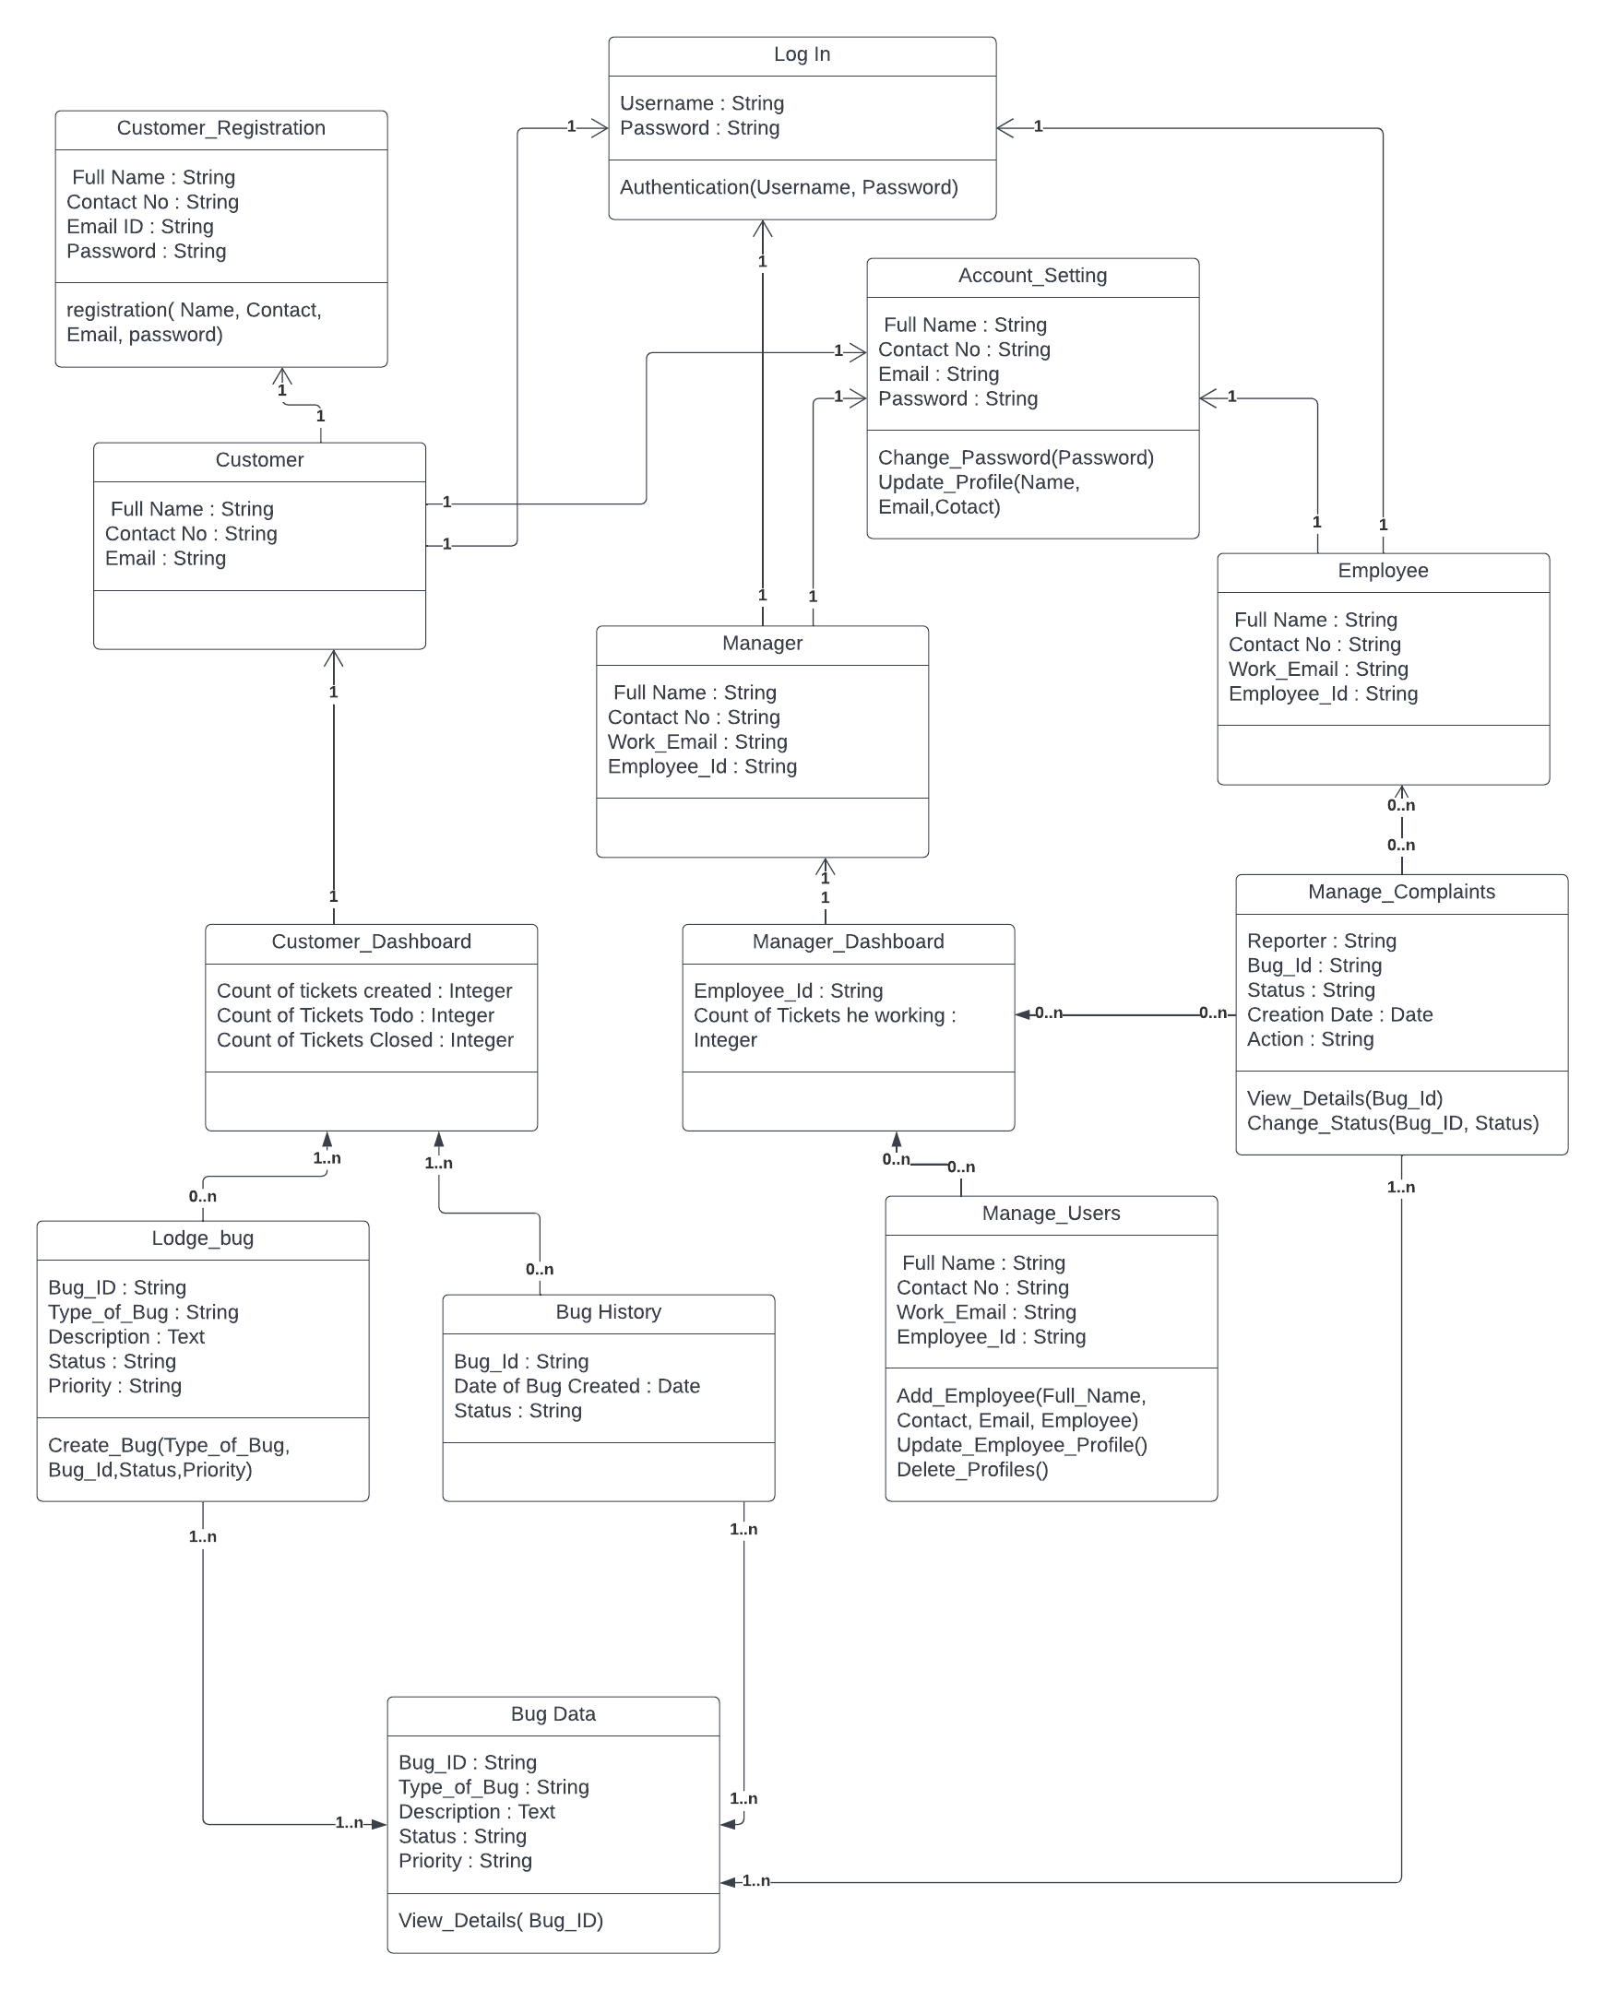

Figure 1: Class Diagram

## Sequence diagram

Sequence diagram for “The Bug Tracking System” with respect to the Phase – 1 Requirements.

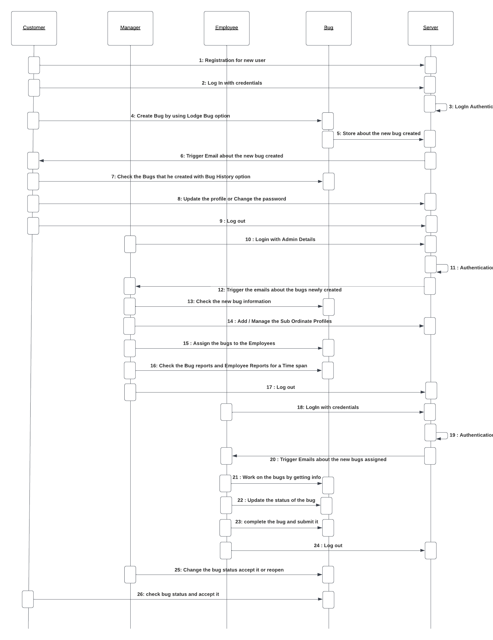

Figure 2: Sequence Diagram

## Use case diagram

Use Case diagram for “The Bug Tracking System” with respect to the Phase – 1 Requirements.

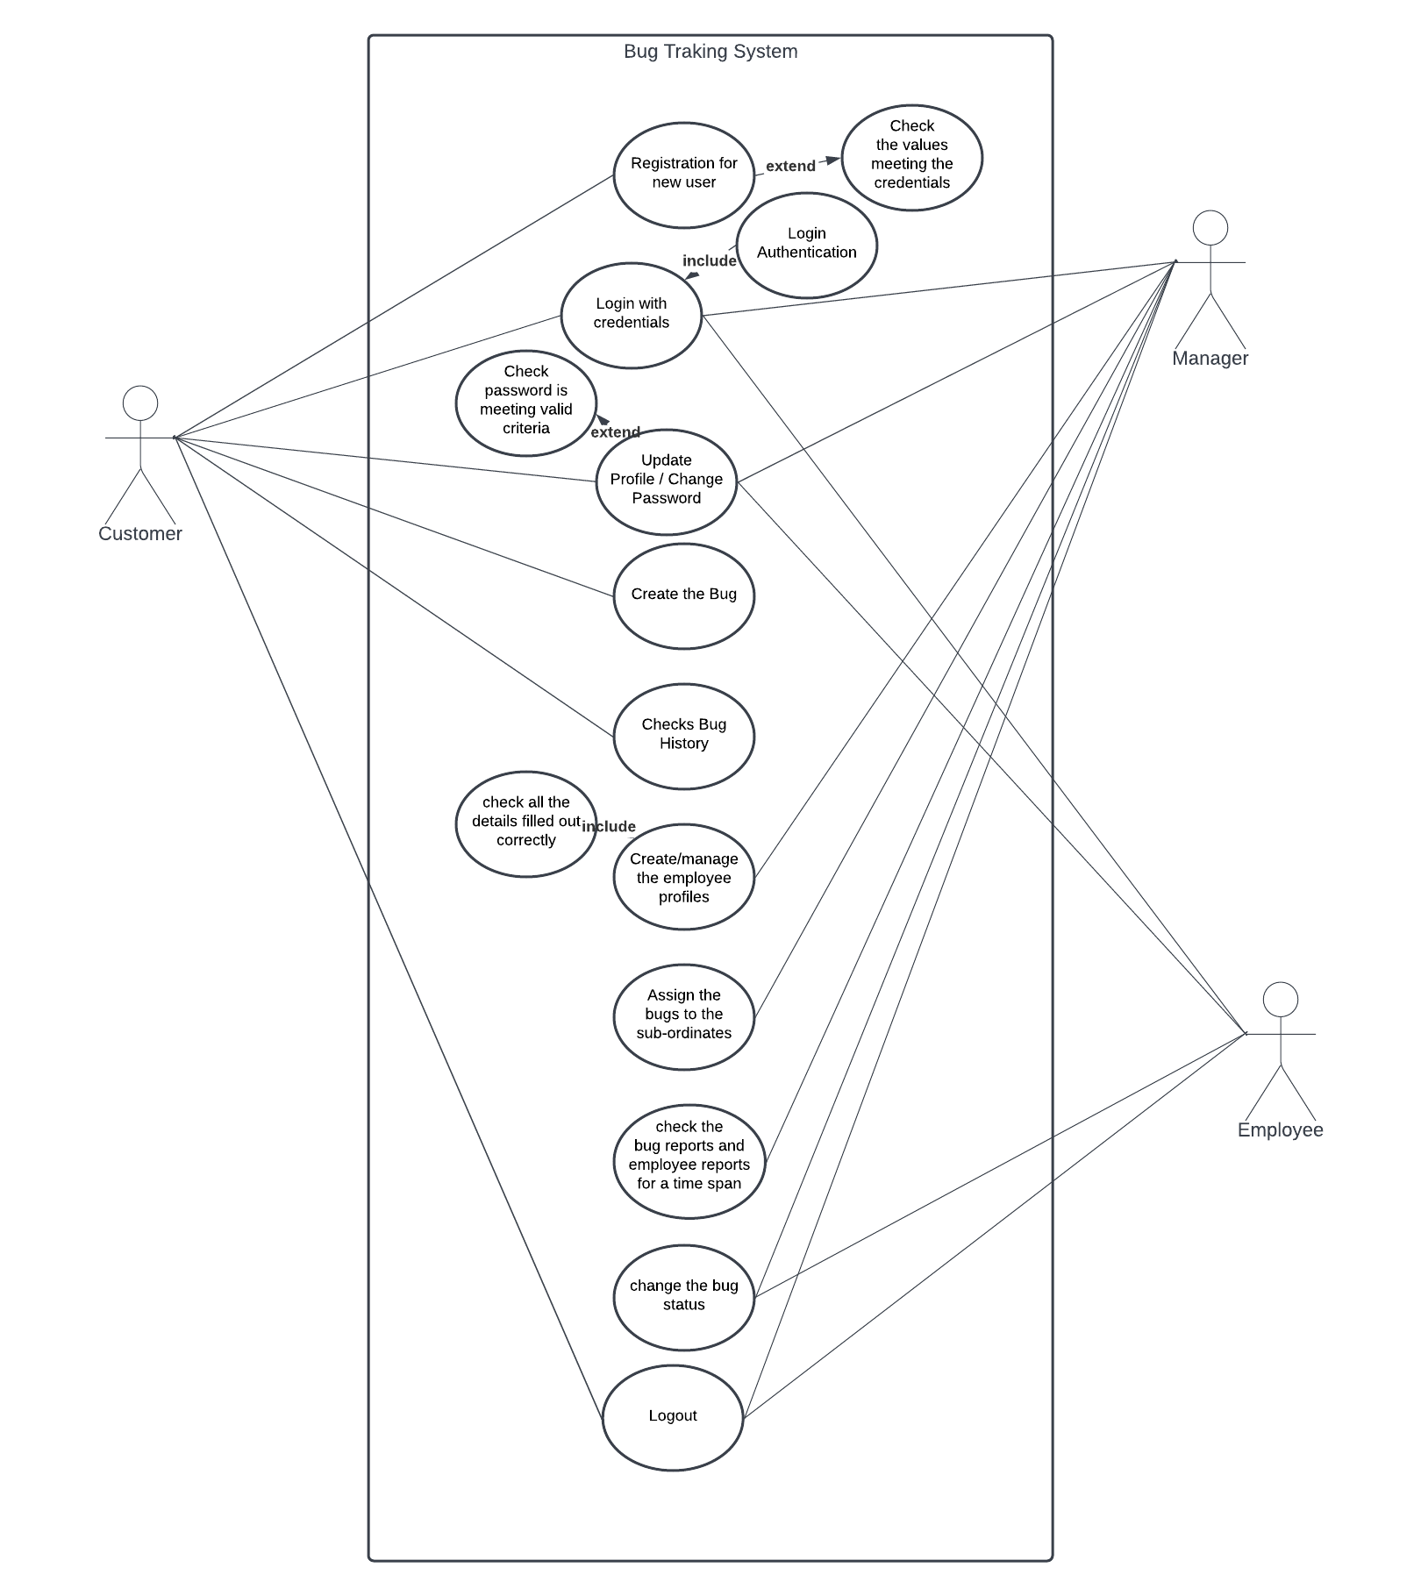

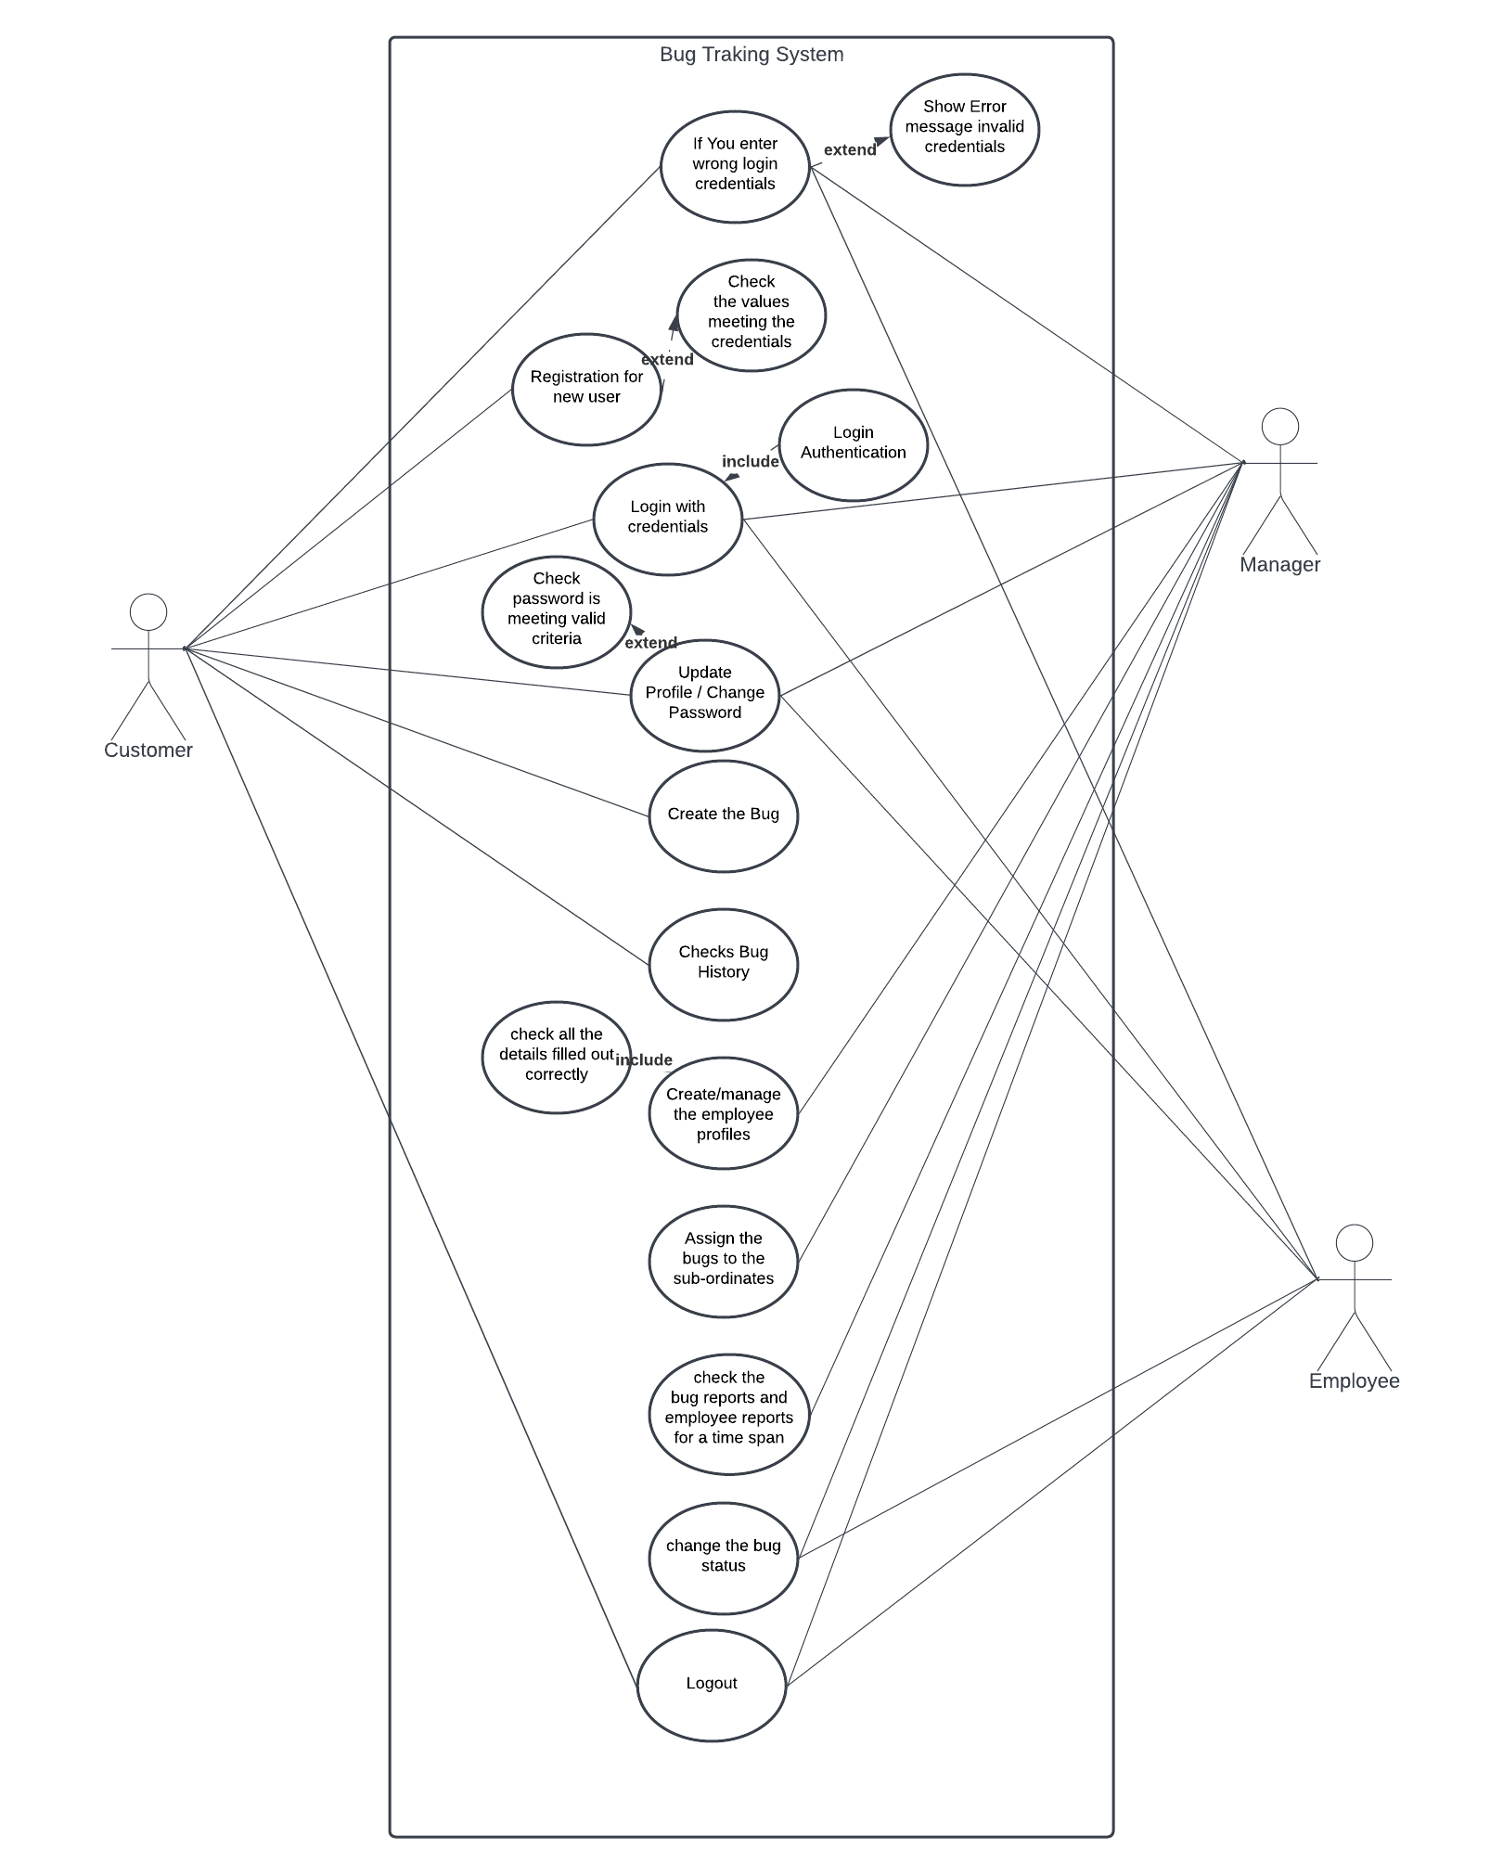

Figure 3: Use-case Diagram-normal case and error case

# Test Cases

## Customer Registration Functionality:

**Input:** Entered incorrect E-mail address and tried to register.

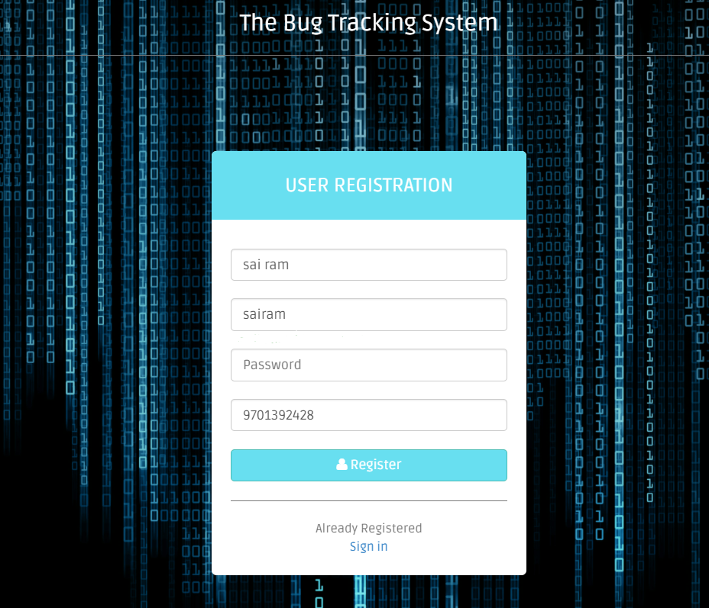

Figure 4: Test Case 1 - incorrect E-mail address

**Output:** Entered incorrect E-mail address, “error message is displayed”.

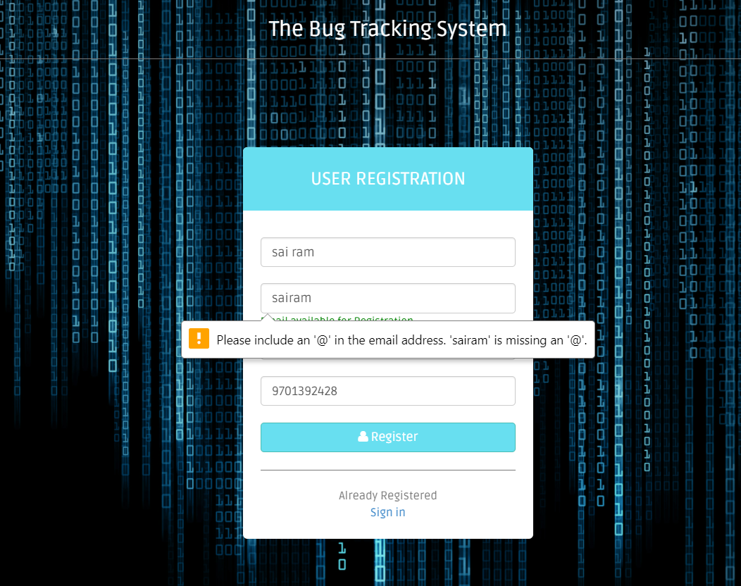

Figure 5: Test Case 1 Incorrect Email ID error

**Functionality:** Once all correct details are captured. Registration should be successful.

* Captured all the required details correctly and clicked on Register.

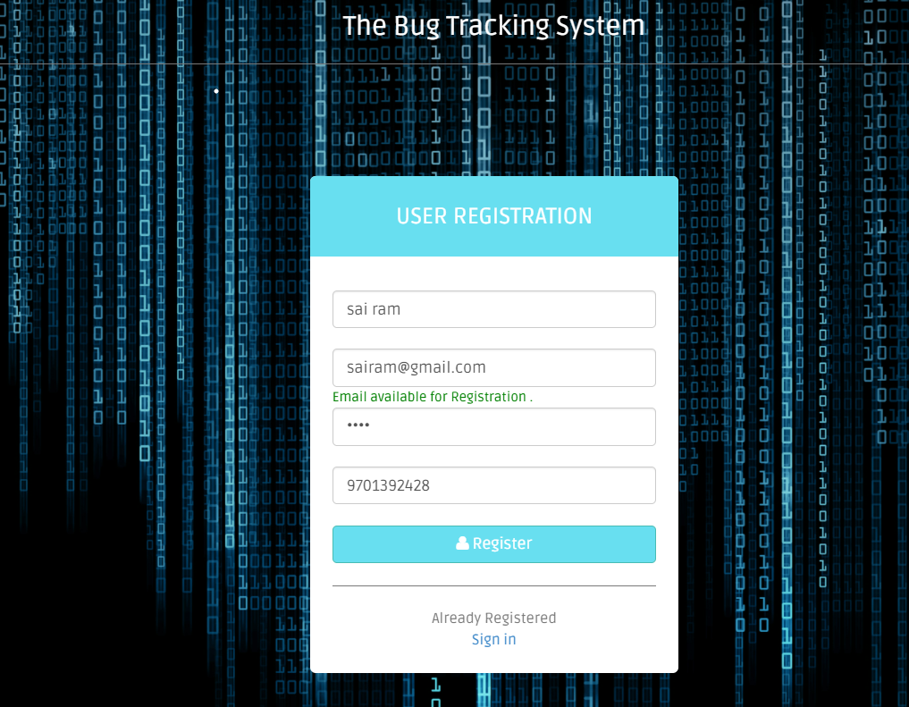

Figure 6: Test Case 1 Valid User Registration details

* User account has Registered successfully.

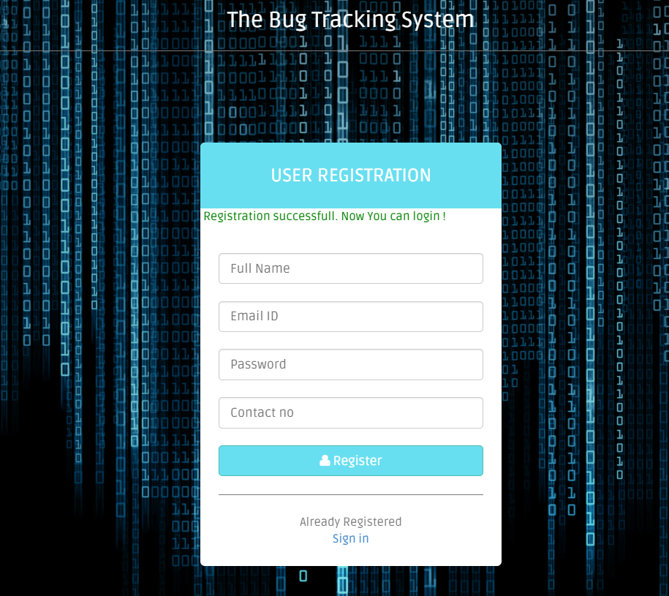

Figure 7: Test Case 1 Successful Customer Registration

## Customer Login Functionality:

**Input:** Entered incorrect E-mail and password.

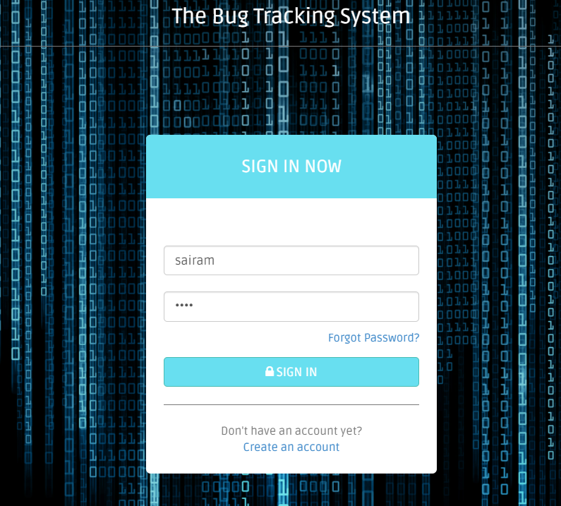

Figure 8: Test Case 2 Incorrect Login details

**Output:** Incorrect username and password error message has popped up.

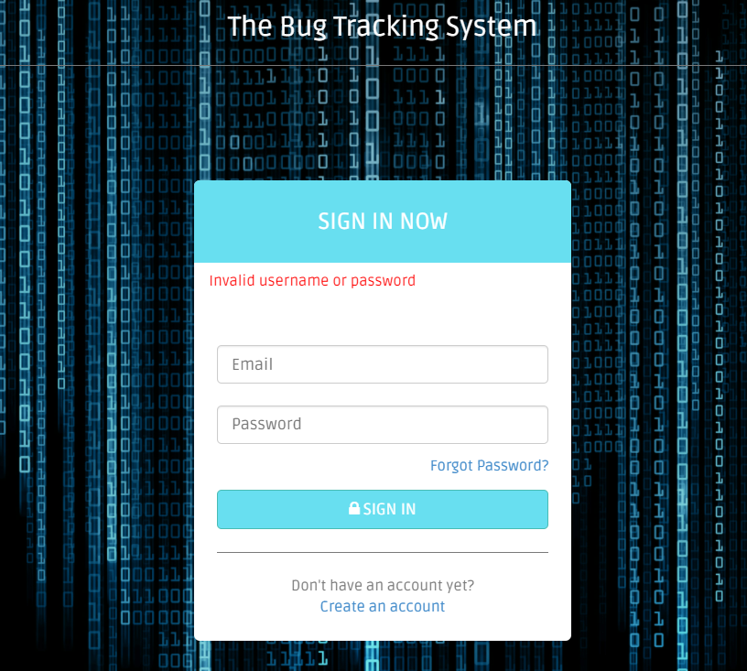

Figure 9: Test Case 2 Invalid username or password

**Functionality:** E-mail Id and Password to be validate. Login should be successful.

* Captured correct E-mail and password. Credentials are validated.

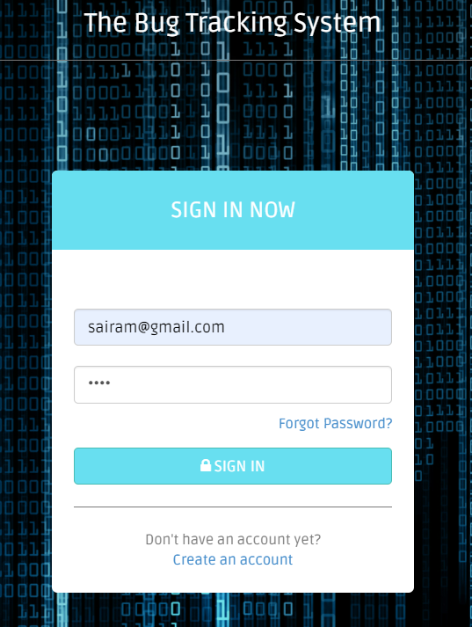

Figure 10: Test Case 2 Valid Customer Credentials

* Account has Logged in successfully.

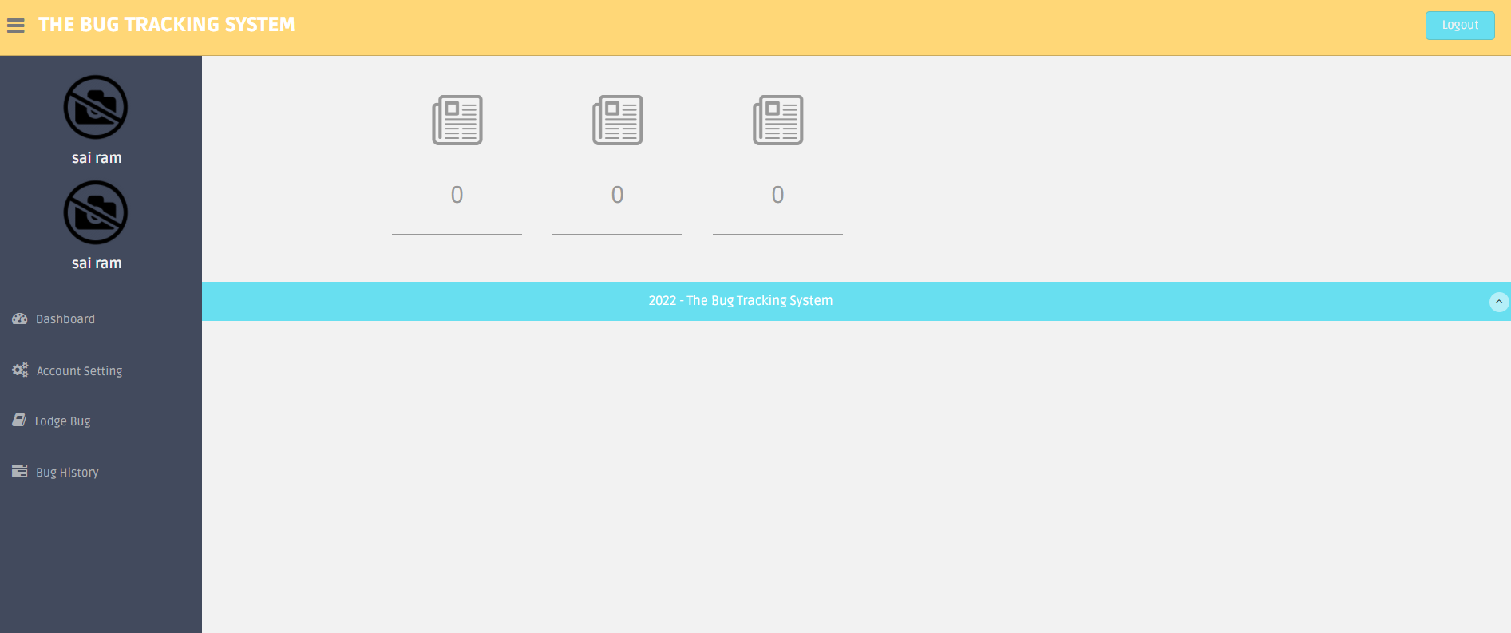

Figure 11: Test Case 2 Successful Login

## Employee/Manager Login Functionality:

Tested by giving the unregistered email address to check whether our website check whether **Input:** Entered Login details which are not registered.

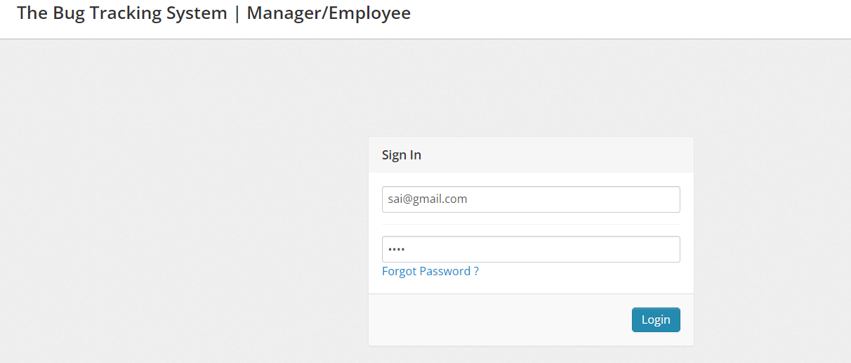

Figure 12: Test Case 3 Incorrect User Credentials

**Output:** Validate the Username and password. Throw error if the credentials are not registered.

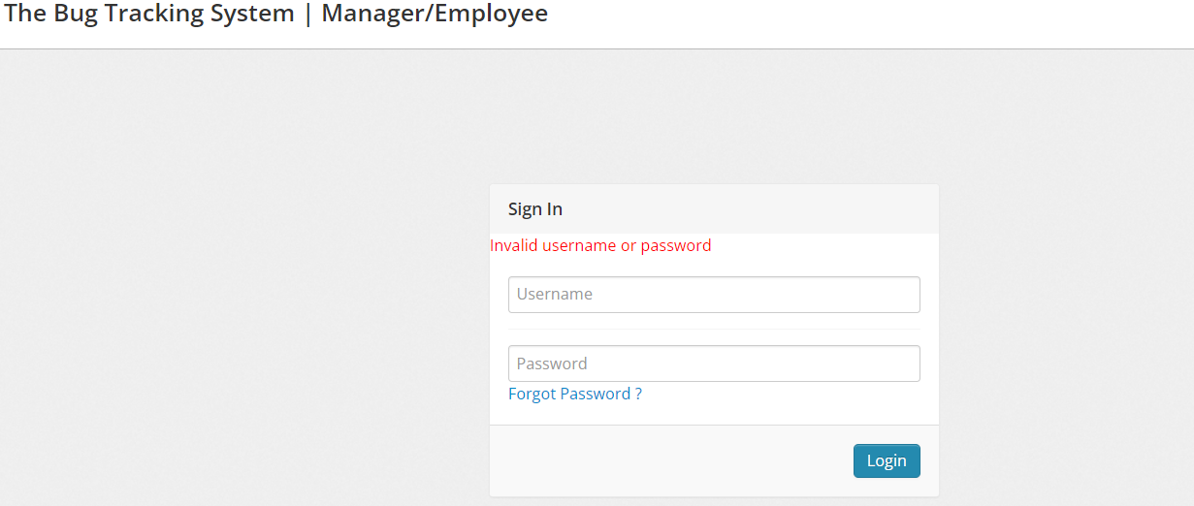

Figure 13: Test Case 3 Invalid username or password

**Functionality:** Enter correct login details which are registered in the system.

* Entered correct login details.

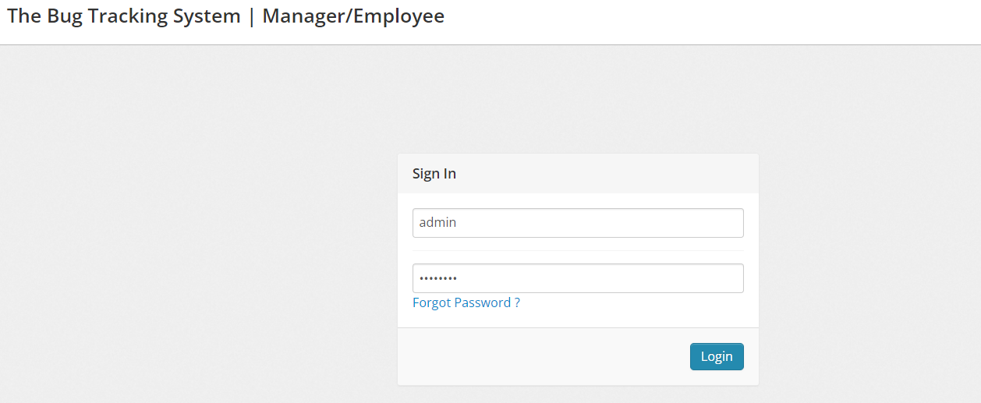

Figure 14: Test Case 3 Correct Login Details

* Account has Logged In.

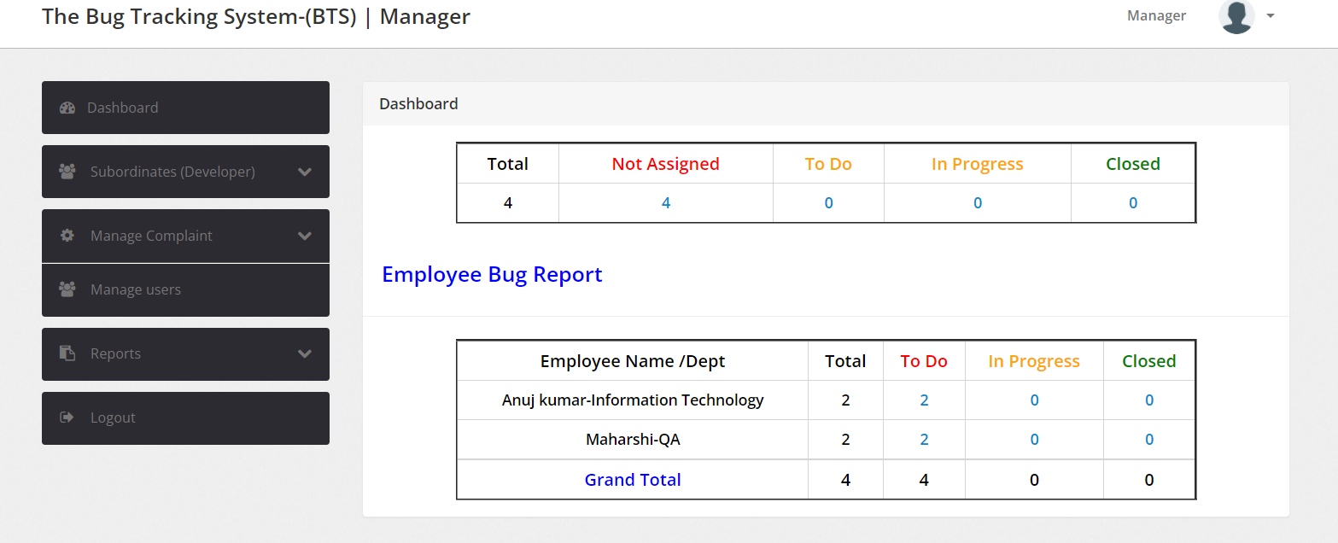

Figure 15: Test Case 3 Successful Login

## Change password:

**Input:** enter new password and confirm password incorrectly.

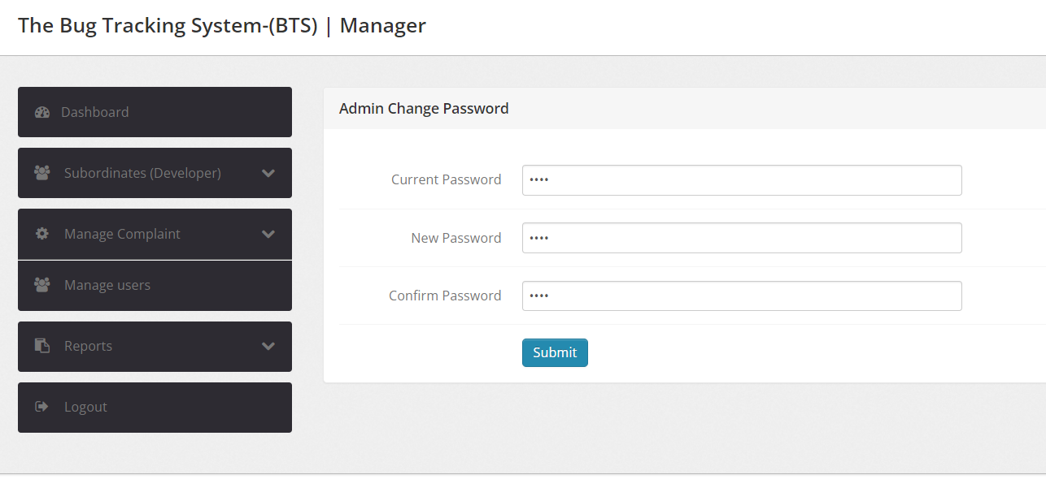

Figure 16: Test Case 4 Change password with incorrect password

**Output:** If password is mis-matched, then pop will be displayed.

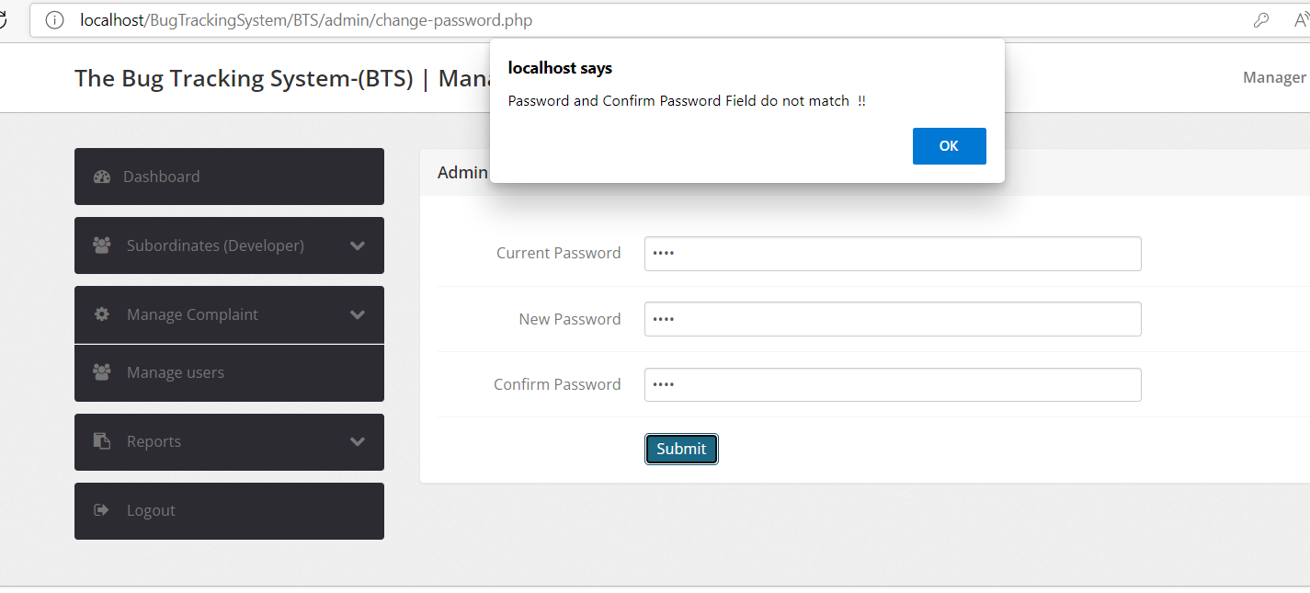

Figure 17: Text Case 4 Password and Confirm Password do not match

**Functionality:** Validate correct new password and confirm password are same. Then change should be saved.

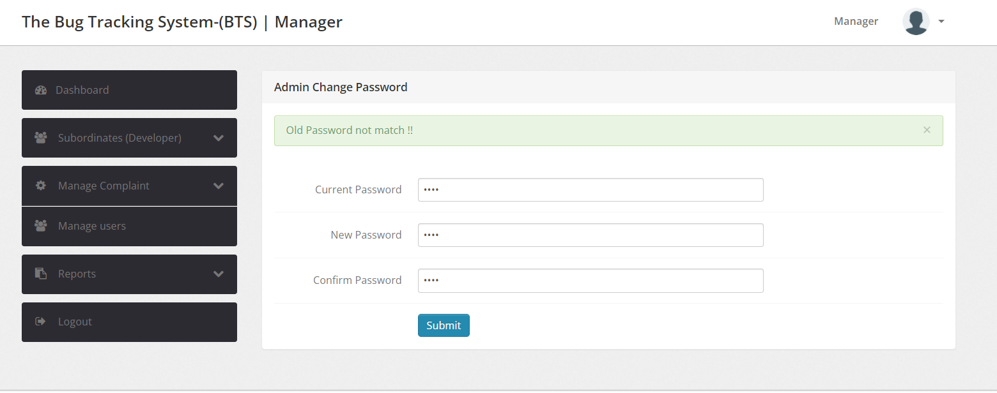

Figure 18: Test Case 4 Wrong Current password

Now Enter Valid Details, password will be saved.

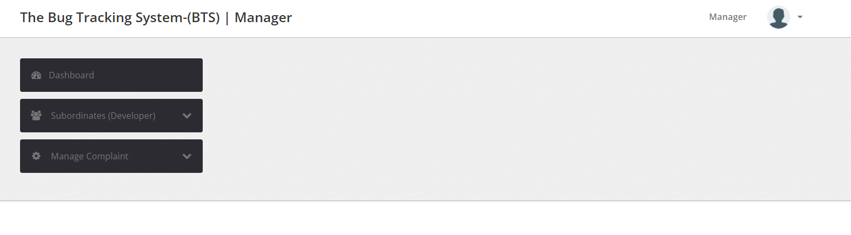

Figure 19: Test Case 4 Successfully changed password

# User Manual for Phase - 1

The Bug Tracking System is a Web Application, used by Customers and Organization to track the bugs in their software.

Follow the Program Compilation and Run Instructions to setup the program on your system and type the URL, main page will be displayed. <http://localhost/BTS>

## Main Page:

Use the Buttons on the top of the “Main Page” to navigate. Customer will use buttons “Customer Login” and “Customer Registration”. Manager/Employee will use “Manager/Employee Login” button.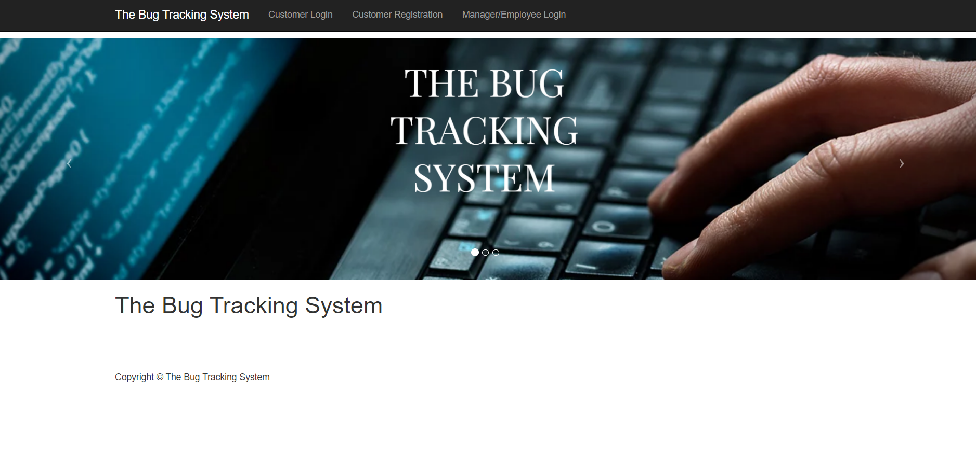

Figure 20: Main Page

### Customer Registration

* This component is specific to Customers.
* Customers can initially register with their organizations email id and password using the button “Customer Registration” on the Main Page.
* Click on the button “Customer Registration”, Registration page will be displayed, fill the details like Full Name, Email Id, Password and Contact No. (Fields validation is also done.)
* Once the account is registered, login by clicking “Sign in” button on the bottom.

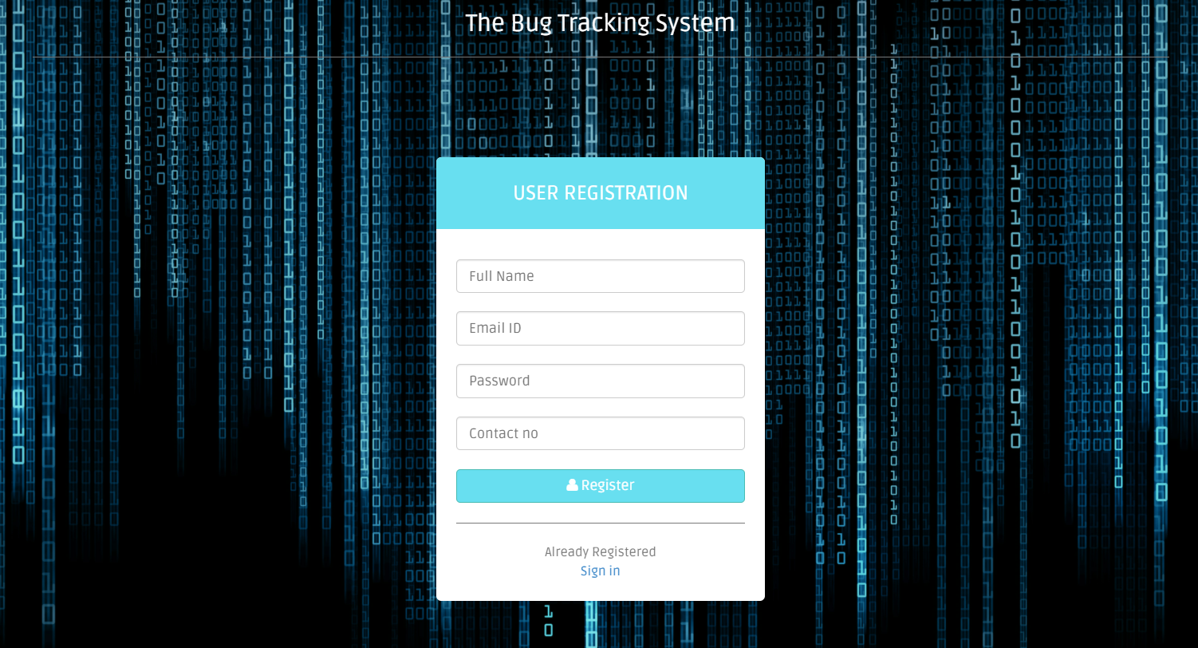

Figure 21: Customer Registration Page

### Customer Login/Sign in

* Click on button “Customer Login” and enter login credentials. (Validation of credentials is done.)

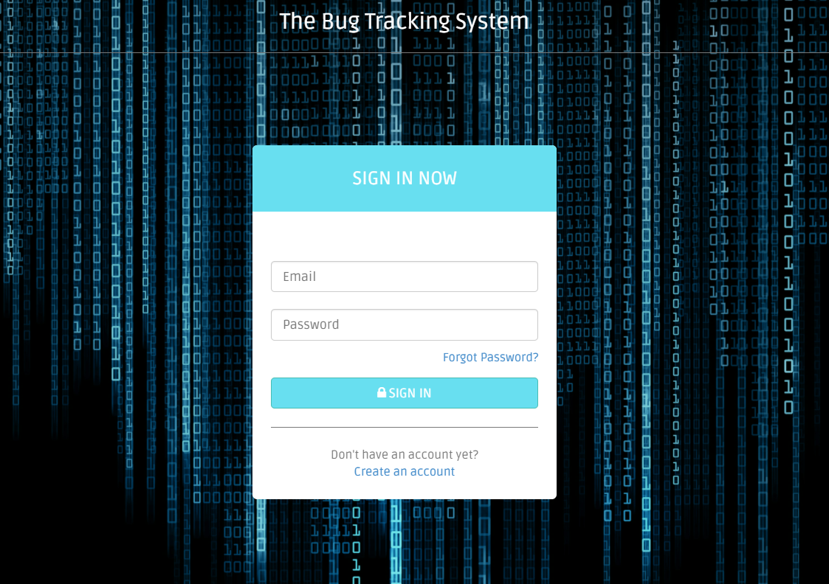

Figure 22: Customer Login Page

* Enter valid details, if not error “Invalid Username or Password” is popped.

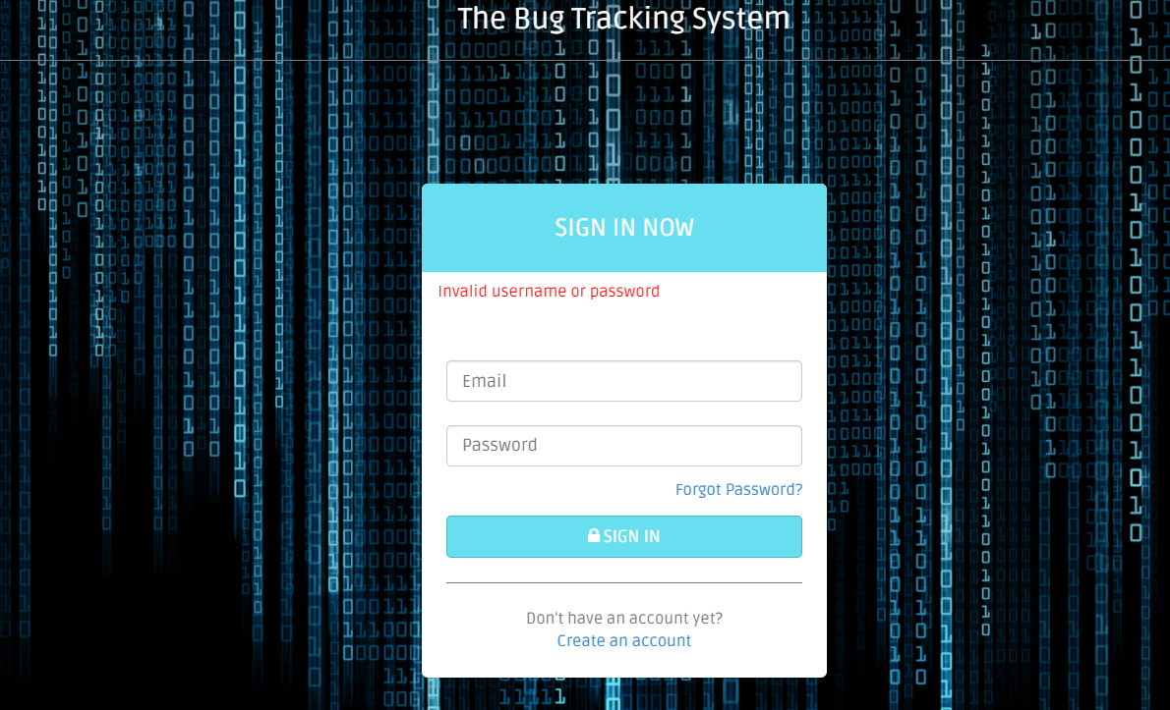

Figure 23: Invalid login details

* “Forgot Password” button is also available to change the password anytime. To change the password, enter Email Id, Contact No., New password and Confirm password fields.
* Once submitted with correct Email Id and Contact No, password will be updated successfully. Cancel option will cancel the password from updating.

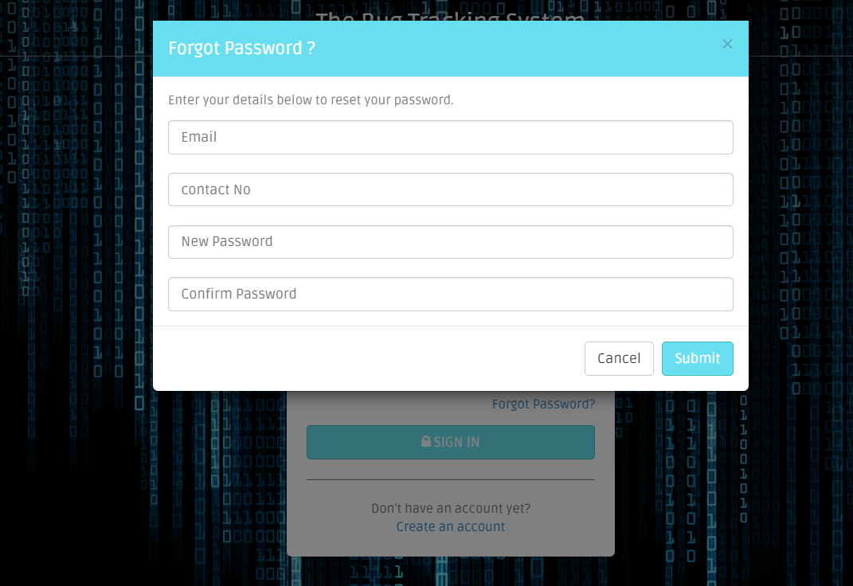

Figure 24: Forgot Password Option

### Manager/Employee Login

#### Manager Login

* Click on “Manager/Employee Login” on the “Main Page” and enter login credentials. Validation of credentials is done. If details are wrong, error “Invalid Username or Password” is popped.

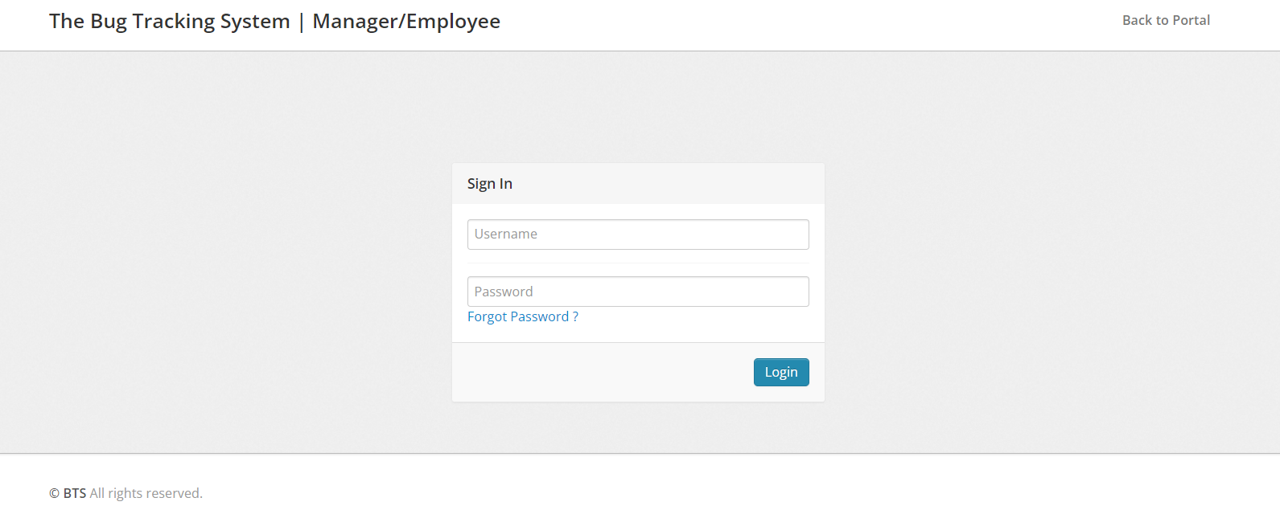

Figure 25: Manager Login Page

* “Forgot Password” button is also available to change the password anytime. It requires User Type (Either Developer or Manager), Username, Email ID/Contact No fields to be filled. Once submitted with correct details, password will be updated successfully.

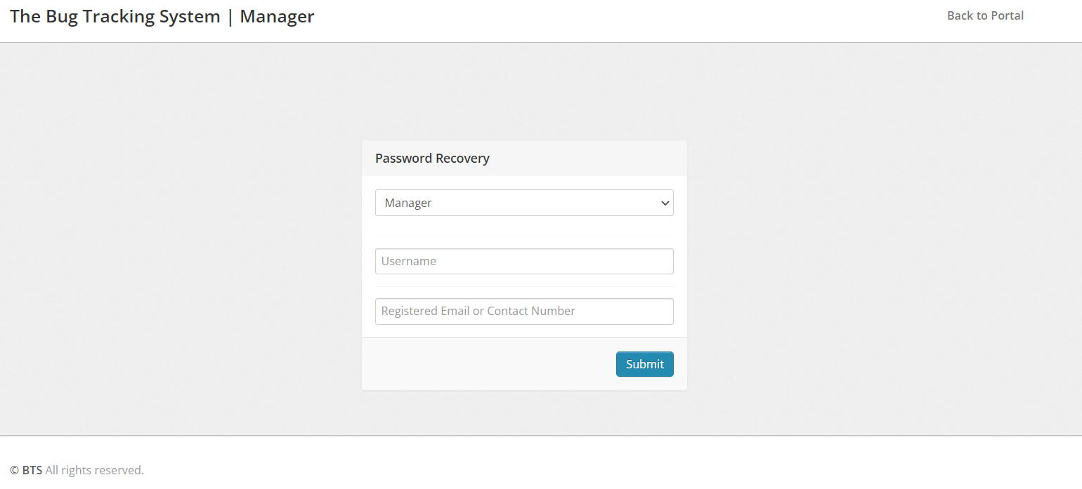

Figure 26: Manager Forgot Password Option

#### Employee Login

* Once manager creates a new employee, they share the credentials to the employee.
* Click on “Manager/Employee Login” on the “Main Page” and enters login credentials. Validation of credentials is done. If details are wrong, error “Invalid Username or Password” is popped.

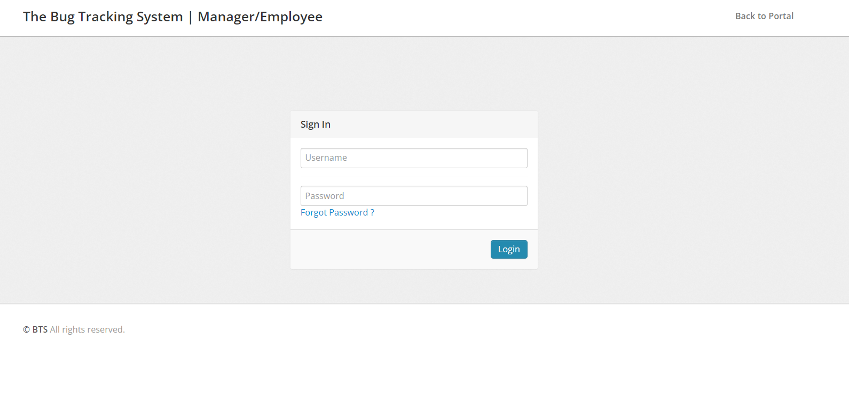

Figure 27: Employee Login Page

* “Forgot Password” button is also available to change the password anytime. It requires User Type (Either Developer or Manager), Username, Email ID/Contact No fields to be filled. Once submitted with correct details, password will be updated successfully.

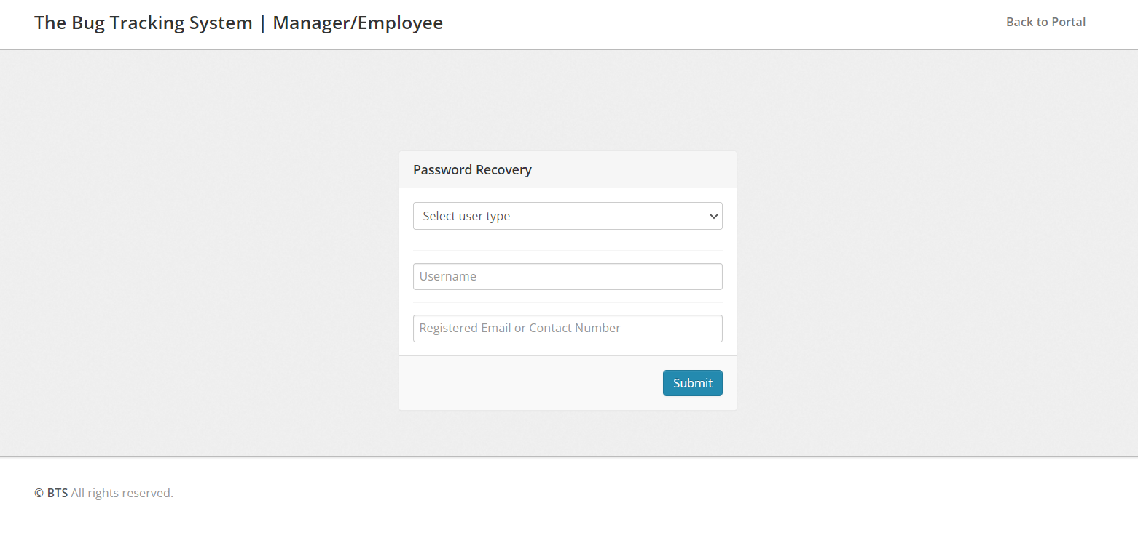

Figure 28: Employee forgot password option

## Customer View

Once the customer logs in, Dashboard is displayed by default. Customer View has following sections:

### Dashboard:

Dashboards display count of all the tickets created by the user that are in To Do, In Progress and Closed.

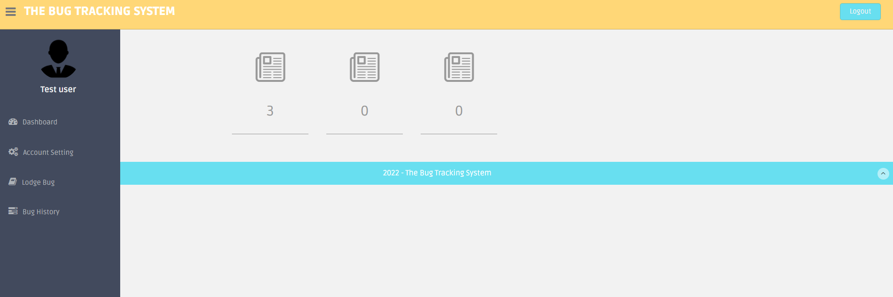

Figure 29: Customer Dashboard Display

### Account Setting:

Account settings have two buttons, profile and change password.

#### Profile:

Profile button will display customers profile information and user can also edit/update personal information.

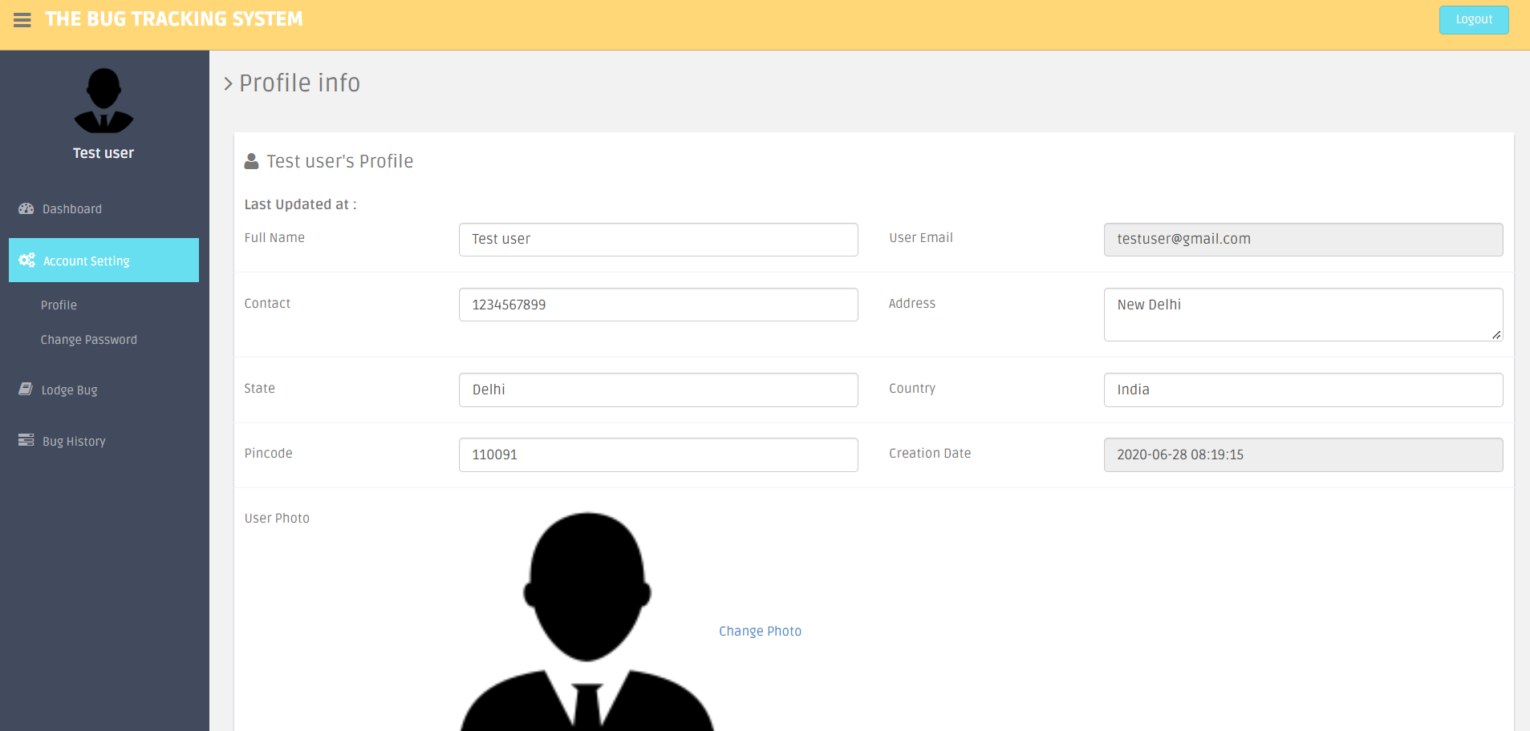

Figure 30: Customer Profile information

#### Change Password:

Change password button is used for changing password. Customer can enter Current password, new password and Confirm password fields and submit for updating the password. If current password is wrong, “Oh Snap! Old password does not match” error is popped.

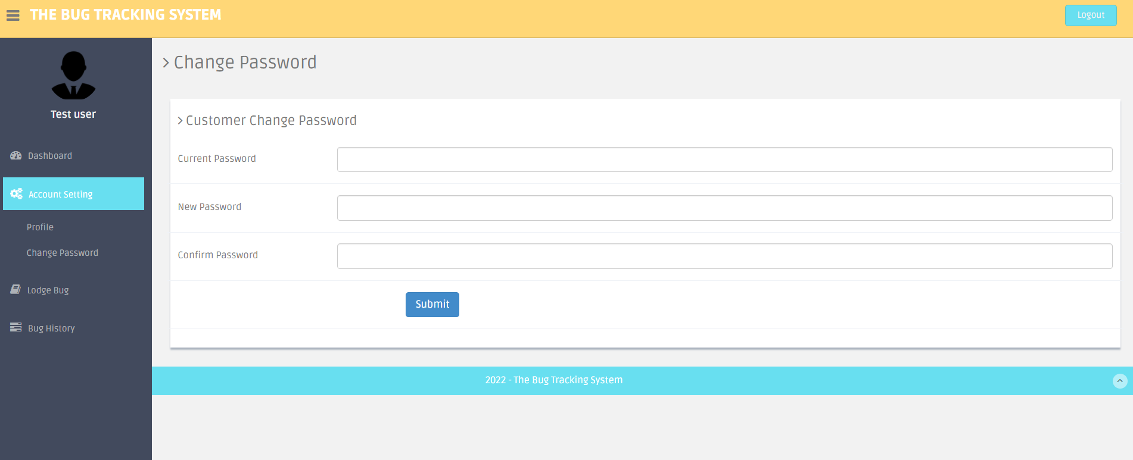

Figure 31: Customer Change Password Page

### Lodge Bug:

Customer uses button “Lodge Bug” to create new Bug/Ticket.

Web page will have below fields in Bug creation page:

1. Type: Type of ticket must be mentioned i.e., either Bug / New (Bug-existing issue, New-new requirement).
2. Summary: Title for the Bug.
3. Description: Describe Bug.
4. Status: It is “To Do” by default while creating.
5. Priority: Set bug priority can be set (low/medium /high).
6. Remarks: Comments can be added.
7. Attachments: Documents/Files related to bug can be uploaded.

Web page will populate below fields in the backend into the same record in the database:

1. Creation Date: Gets timestamp and populates this field.
2. Reporter: Current user will be the Bug reporter.
3. Last Updated Date: Timestamp of last updated changes.

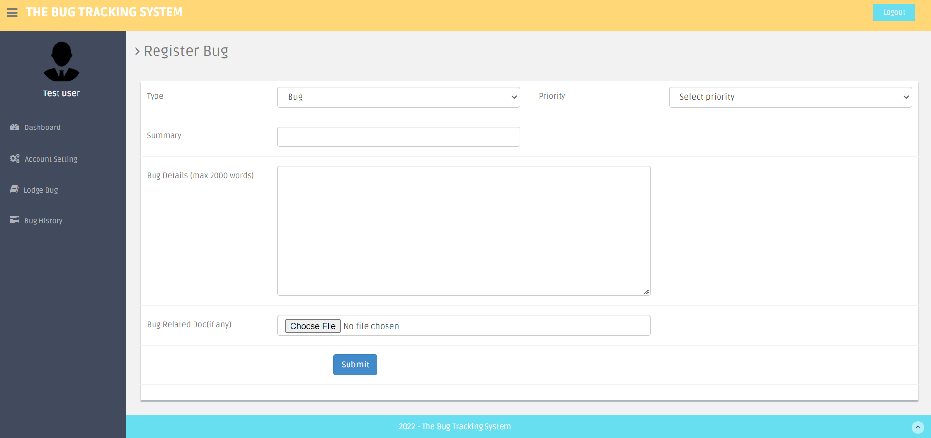

Figure 32: Bug Creation

### **Bug** History:

* Bug History Button displays all the bugs that were created by the customer.

Customer can view all the bugs that were created by current customer.

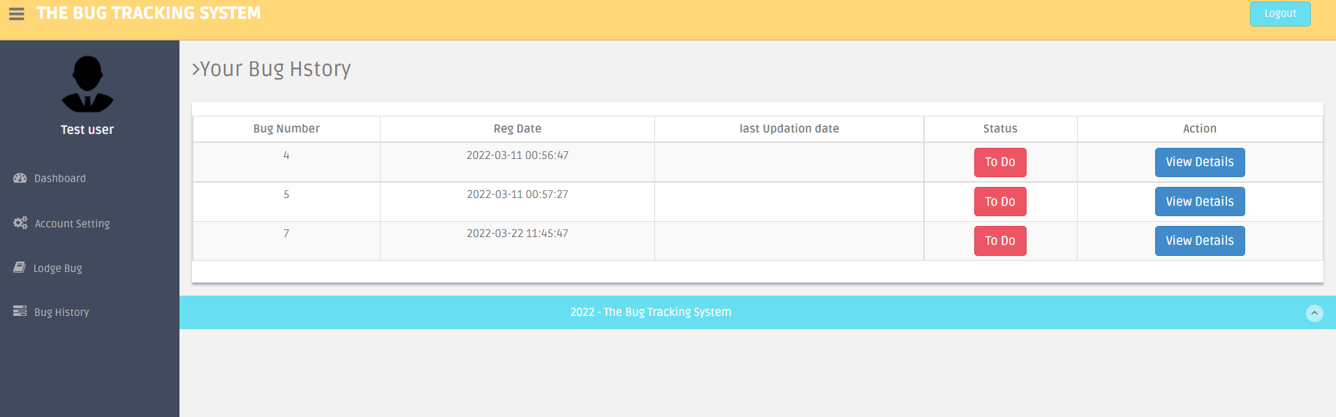

Figure 33: Customer Bug History Page

* By clicking on “View Details” button in the Action Column, customer can view bug details.

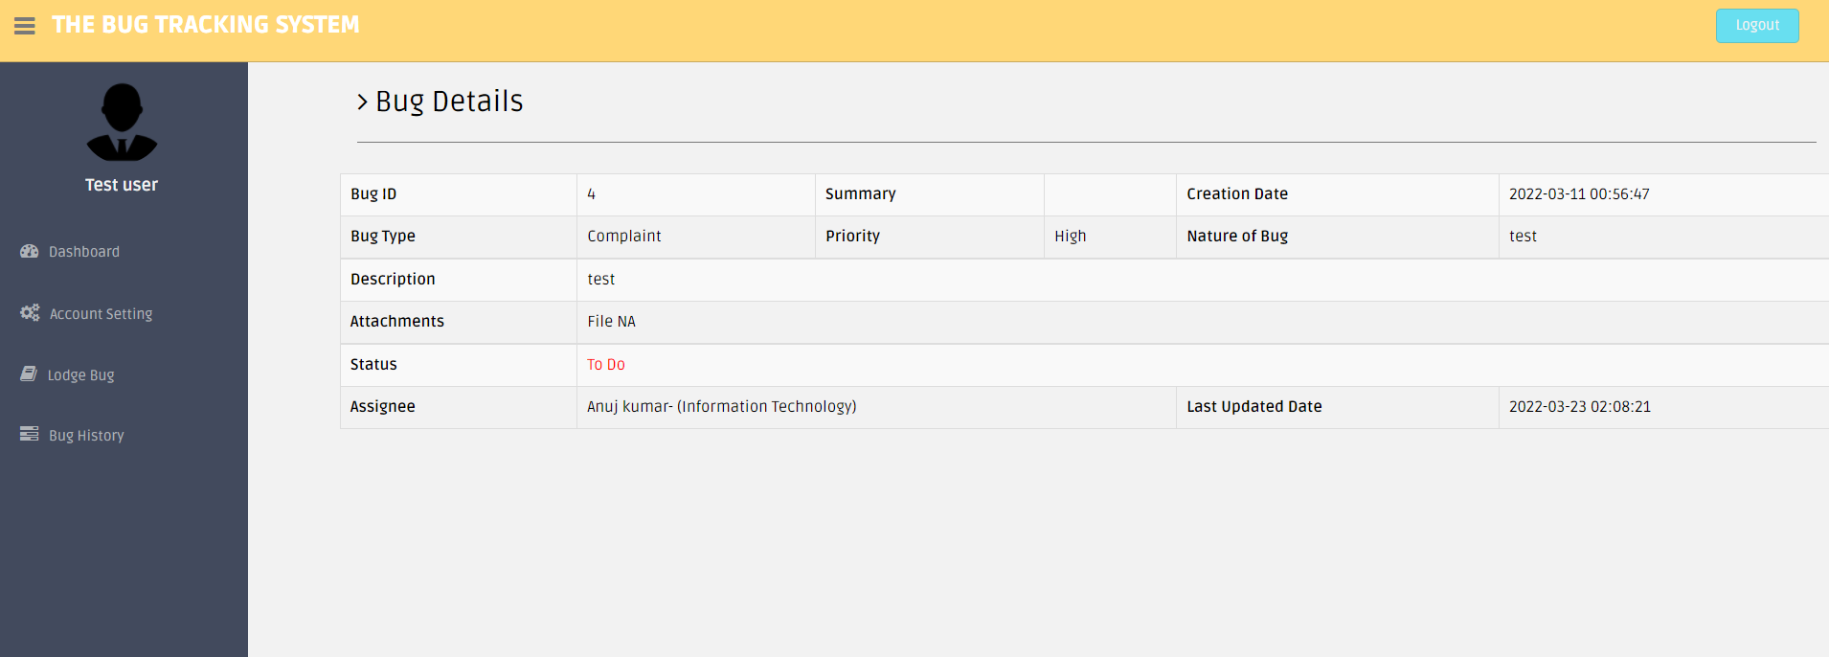

Figure 34: Customer Bug Details Page

## Manager View

Once the manager logs in, Dashboard is displayed by default.

### Account Setting:

Account settings can be accessed by clicking on the icon on the top-right corner. It has three main functions:

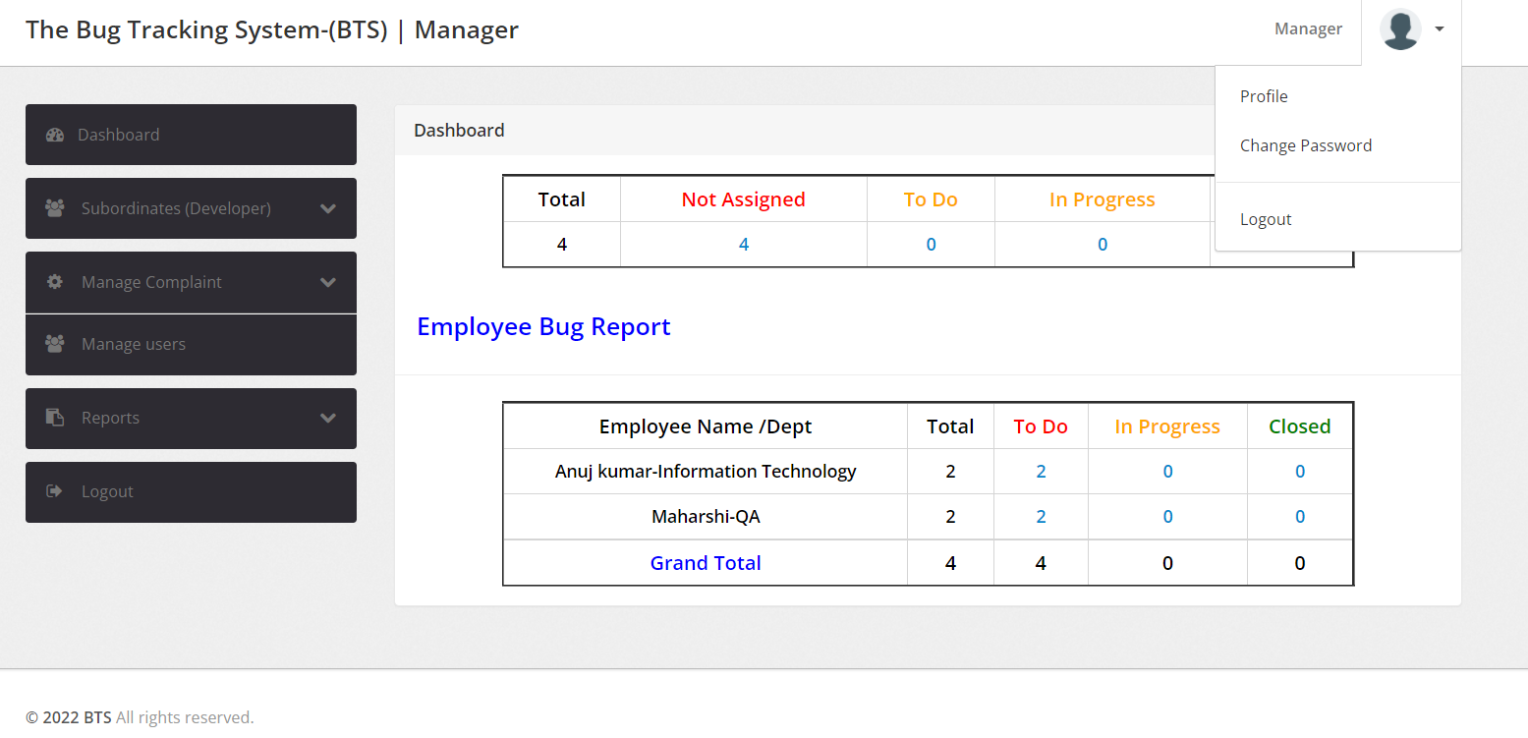

Figure 35: Manager Account Settings

#### Profile:

“Profile” button will display manager profile information and manager can also edit/update personal information.

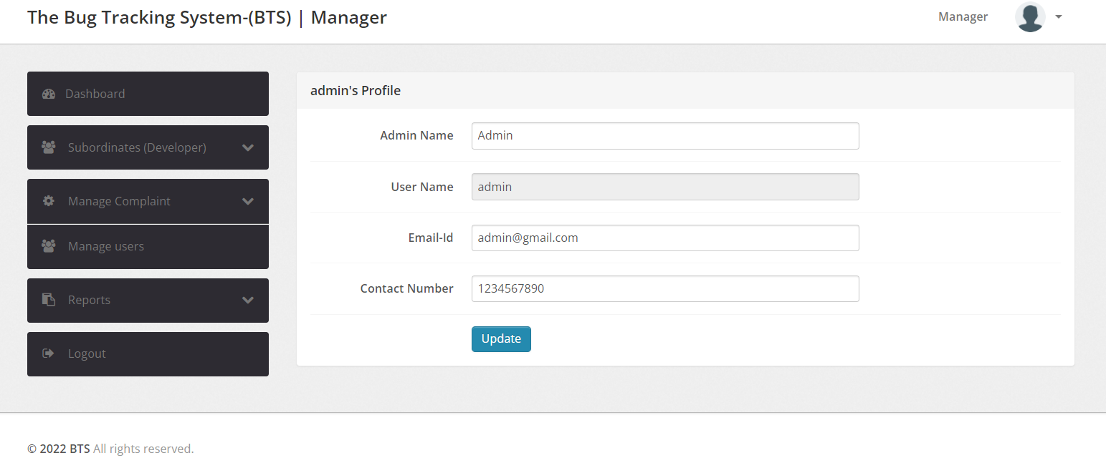

Figure 36: Manager Profile Information

#### Change Password:

“Change password” button is used for changing password. Customer can enter Current password, new password and Confirm password fields and submit for updating the password. If current password is wrong, “Oh Snap! Old password does not match” error is popped.

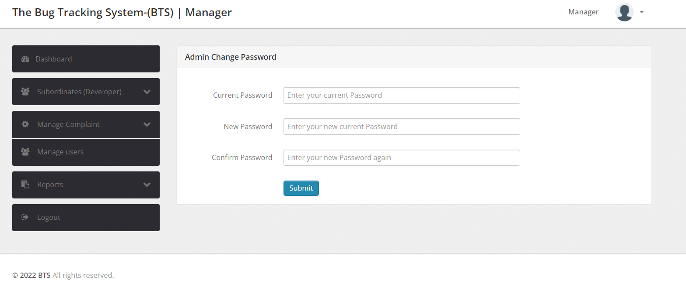

Figure 37: Manager Password Change Page

#### Logout:

User can logout just by clicking this button.

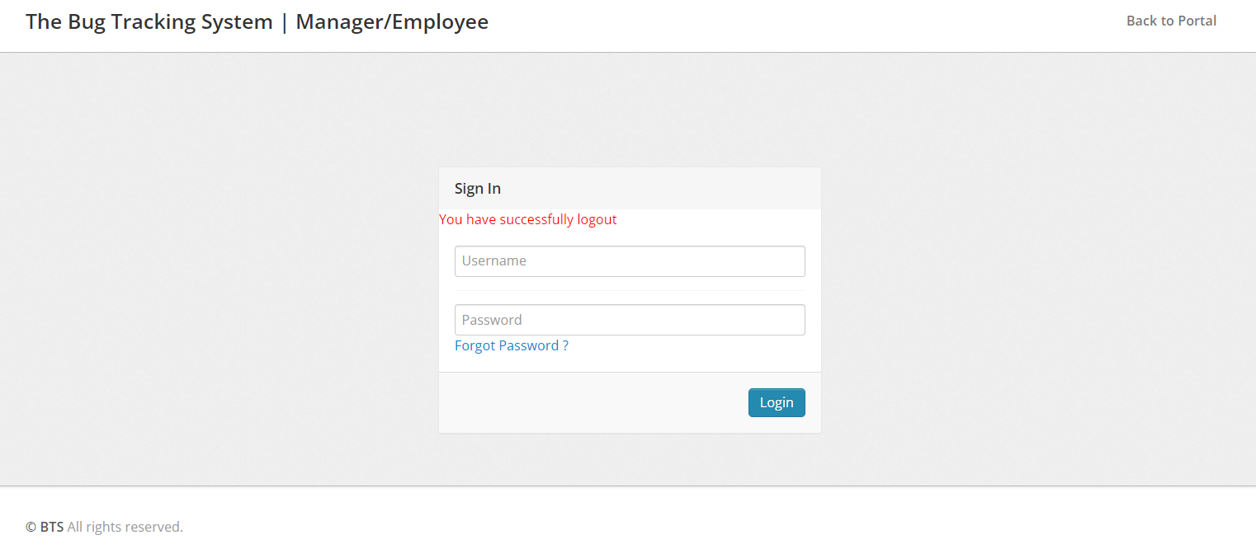

Figure 38: Manager successful Logout

### 3.2 Dashboard:

Dashboard interface displays all the tickets the employees and manager are currently working on.

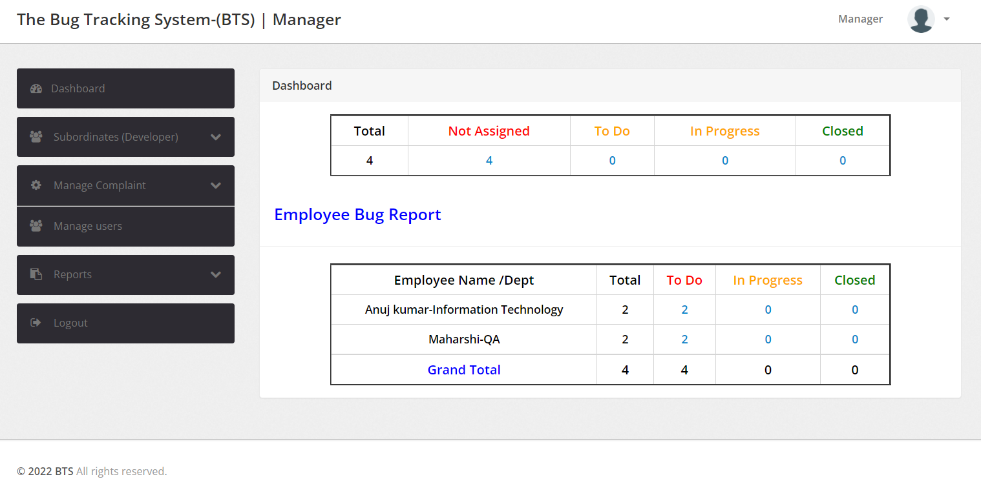

Figure 39: Manager Dashboard Display

### Subordinates:

Manager is the admin and can add new employees to the database from the “Subordinates” section. Also, employee details can be managed, edit button will update the details.

#### Add Developer:

New employee can be added from this section. Employee Name, Employee Department, Email ID, Contact Number, Username (for logging in) and Password (can be later changed by the employee) details should be entered and submitted to create a new employee.

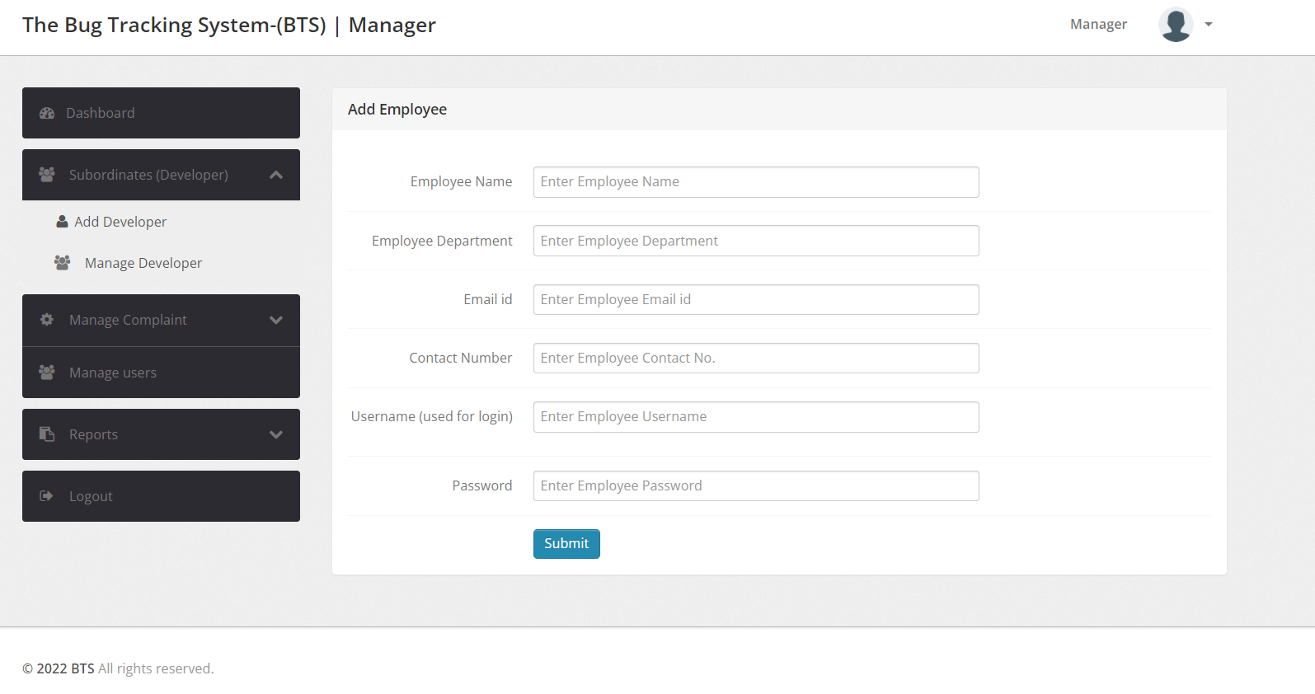

Figure 40: Manager Add Developer Page

#### Manage Developers:

It displays all employees under the manager**,** click on “Edit” button under action column against the employee to update details**.** Employee Name, Employee Department, Email ID, Contact Number and Employee Status (Active or Blocked) can be updated.

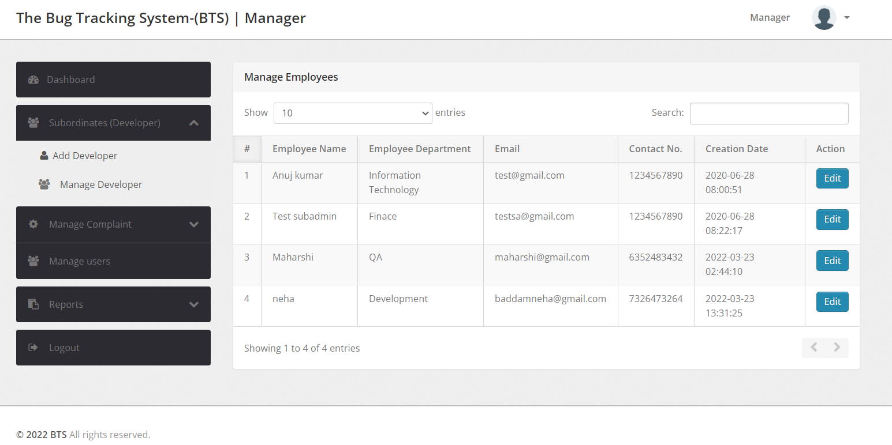

Figure 41: Manager Manage Developers Page

### Manage Complaints:

* This section shows all the To Do, Un-assigned, Closed and In Progress tickets.
* It displays Bug ID, Reporter, Creation Date, Status and Action Columns for the tickets.

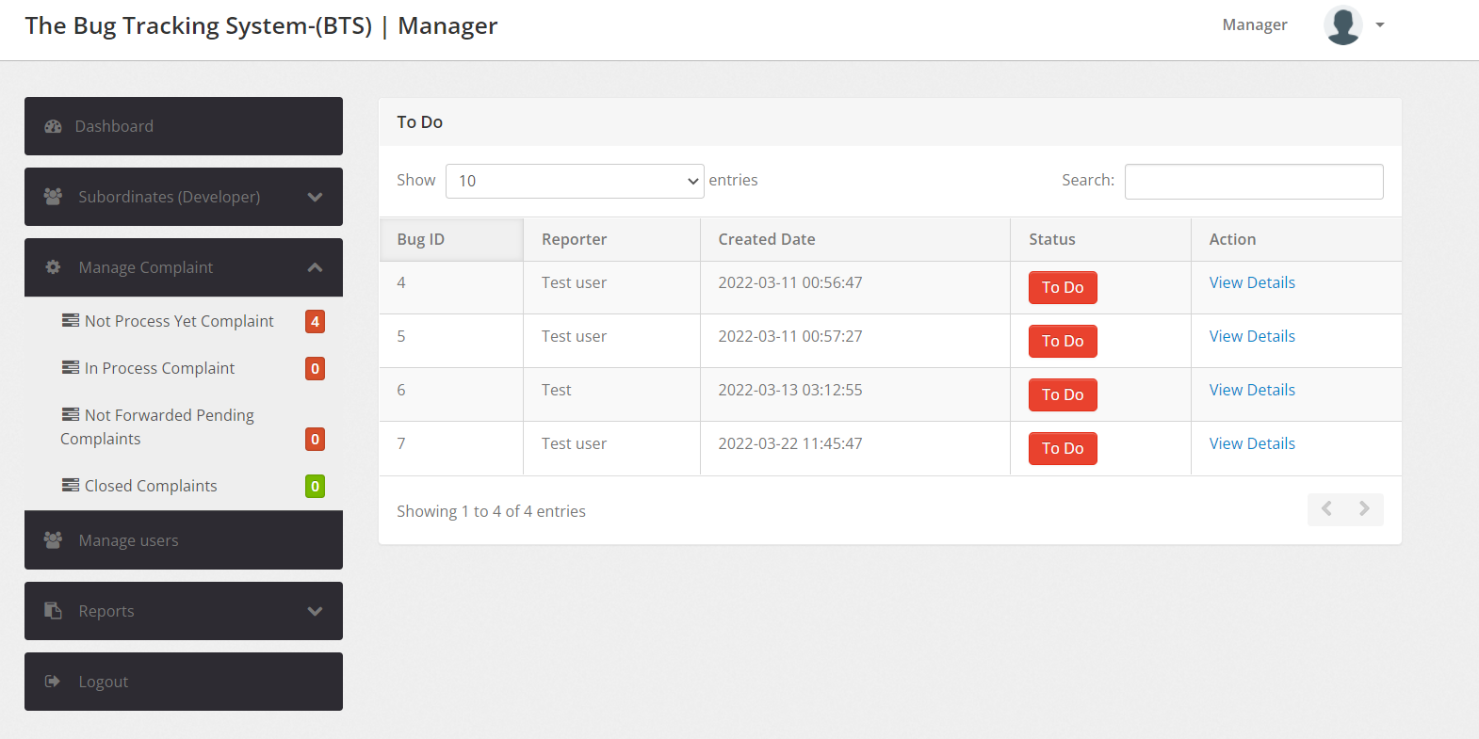

Figure 42: Manager Manage Complaints Page

* Manager can click on “View Details” button in Action column against the Bug to view Bug Details.

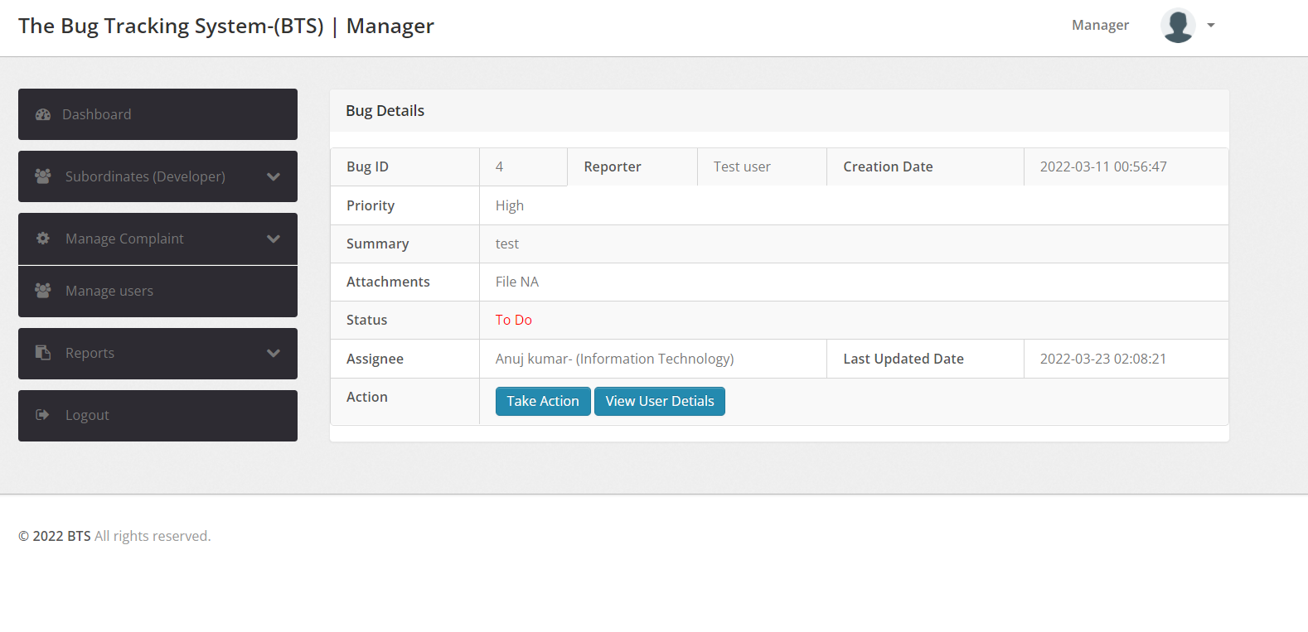

Figure 43: Manager Bug View Page

Action has two buttons “Take Action” and “View User Details”

* **Take Action:** This Button is used to update Bug status and add remarks. Click on “Submit” to update and “Close this window” to close the window.

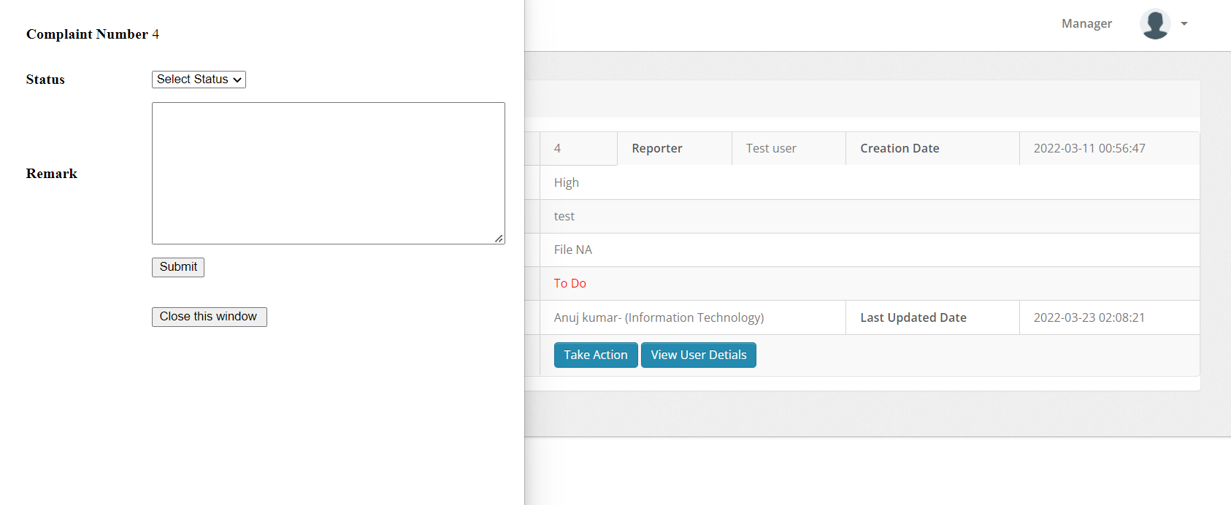

Figure 44: Bug View Take Action button

* **View User Details**: This Button is used to display all the information of the Reporter.

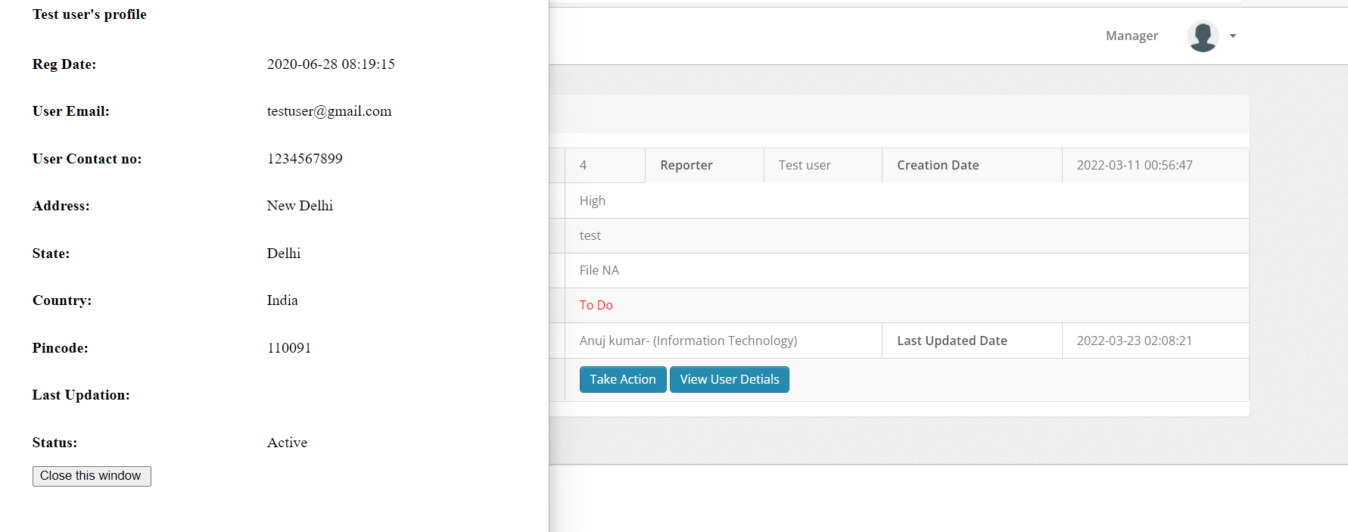

Figure 45: View User Details

### Manage Users:

This section will help in managing employees i.e., either delete or view employee details. This shows Employee name, Email ID, Contact No., Creation Date and Action Column. Action Colum has two buttons as following:

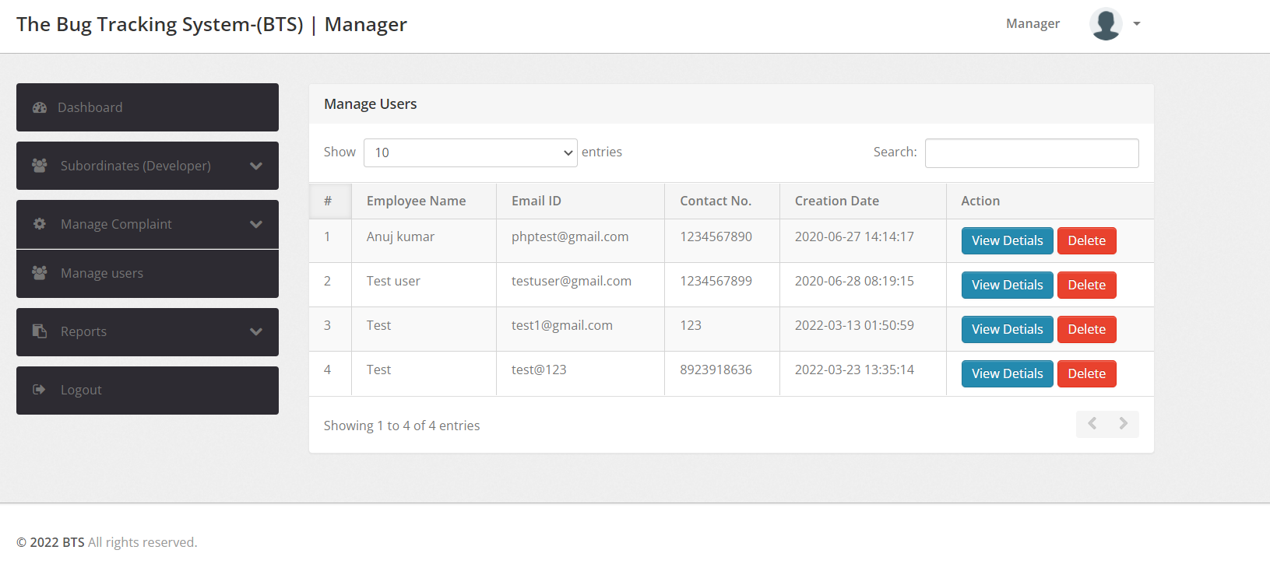

Figure 46: Manager Manage Users Page

1. **View Details:** Displays Employee Details. Use button “Close this window” to close this window.

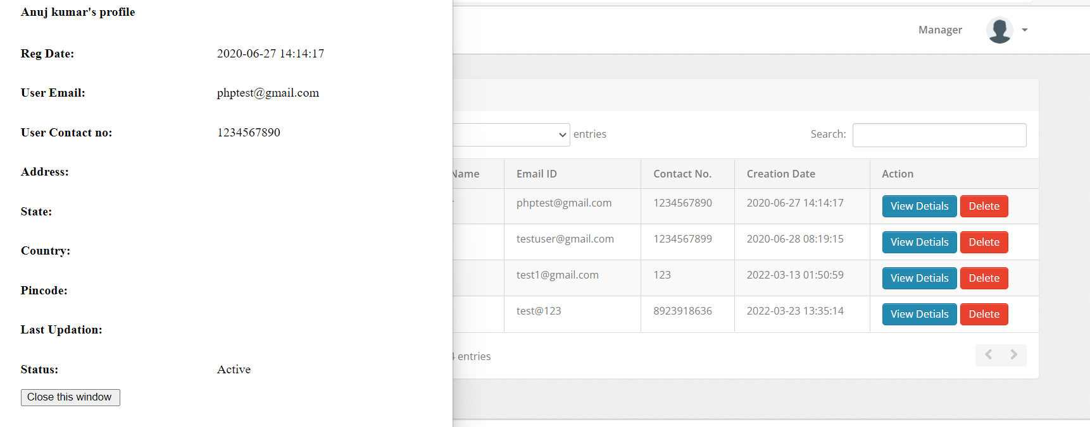

Figure 47: Manager View Employee Details

1. **Delete:** Delete will remove the user from the database.

### Reports:

There are two different reports that can be displayed.

#### B/W Dates Report:

* Enter From and To Date from the calendar and click on “Submit” to display all Bugs Between the selected dates.

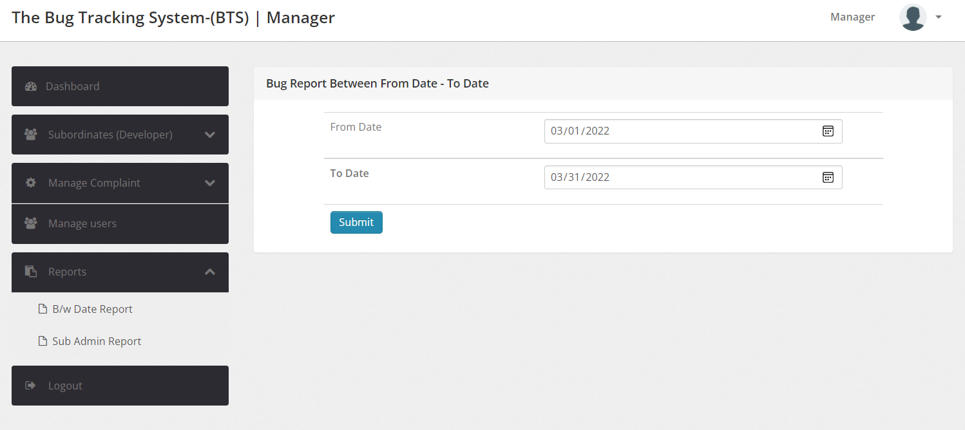

Figure 48: B/W Date Report

* It displays Bug ID, Reporter, Creation Date, Status and Action Columns of each Bug between the selected dates.

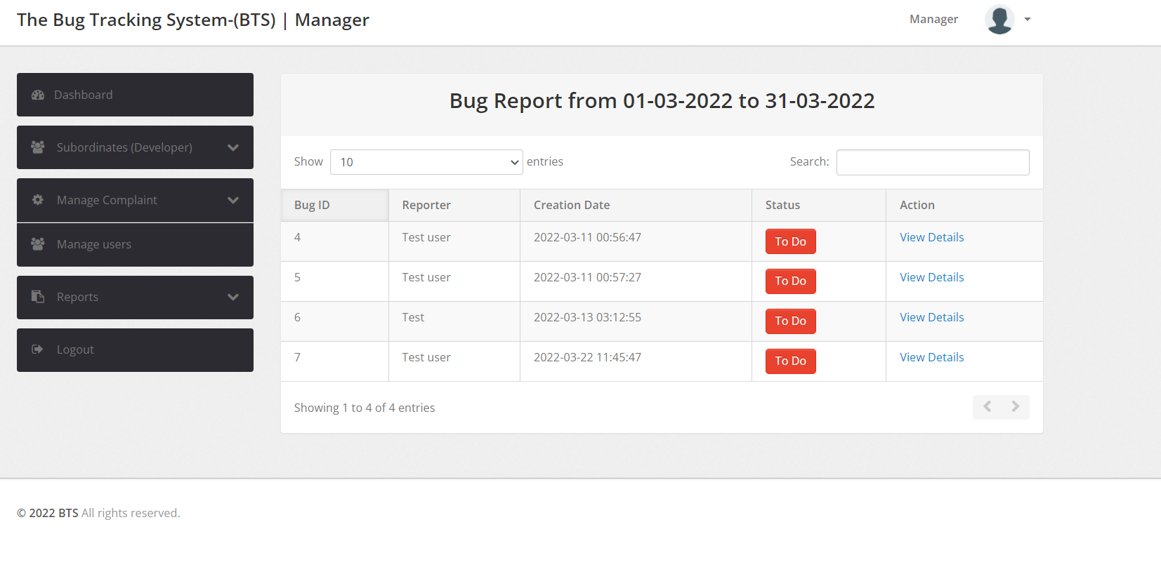

Figure 49: Bug Report between specified dates

* Action Column has **“View Details”** button, this redirects to the Bug View.

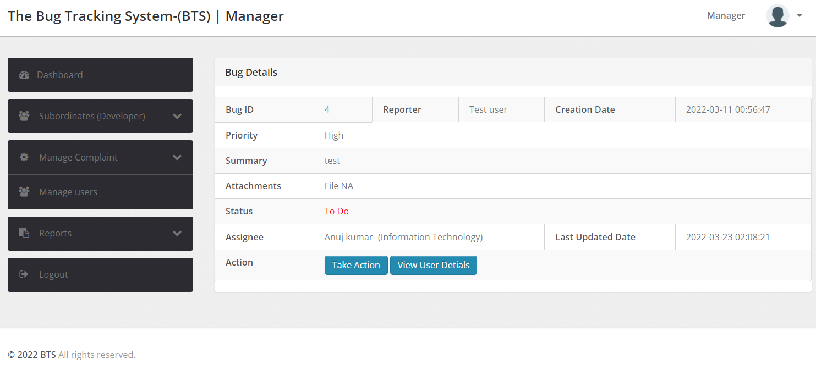

Figure 50: Bug View Page re-directed from Bug Report Page

#### Sub Admin Report:

* Enter From and To Date from the calendar and click on “Submit” to displays all Employee Bug Details Between the selected dates.

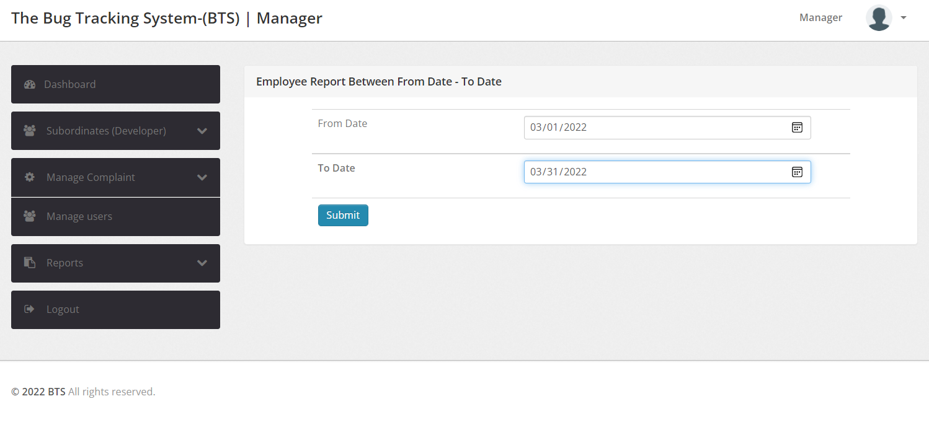

Figure 51: Sub-Admin Report

* It Displays Employee Name – Department, Total, To Do, In Progress and Closed Bugs with respect to each employee under the manager.

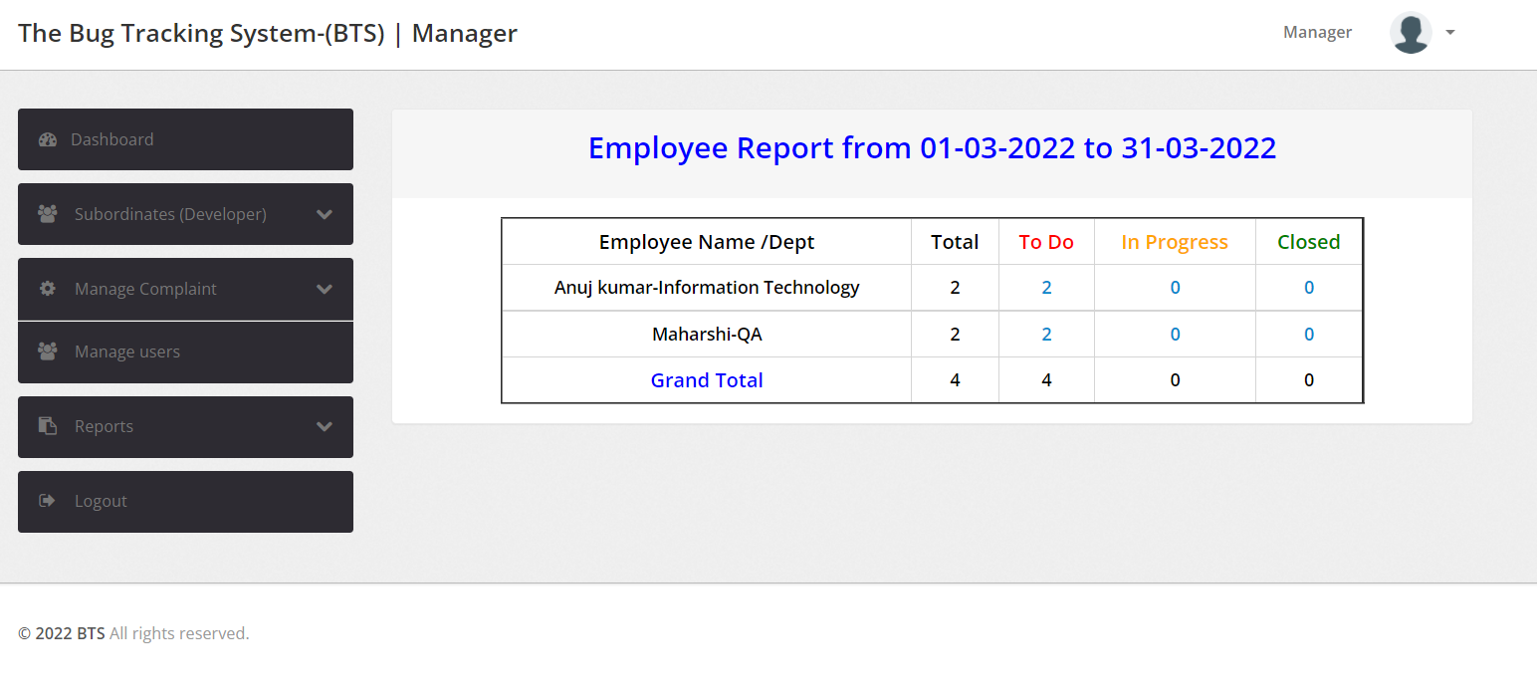

Figure 52: Employee Report between specified dates

### Logout:

This button will log the user out.



Figure 53: Manger logout

## Employee View

Once the employee logs in, Dashboard is displayed by default.

### Account Setting:

Account settings can be accessed by clicking on the icon on the top-right corner. It has three main functions: 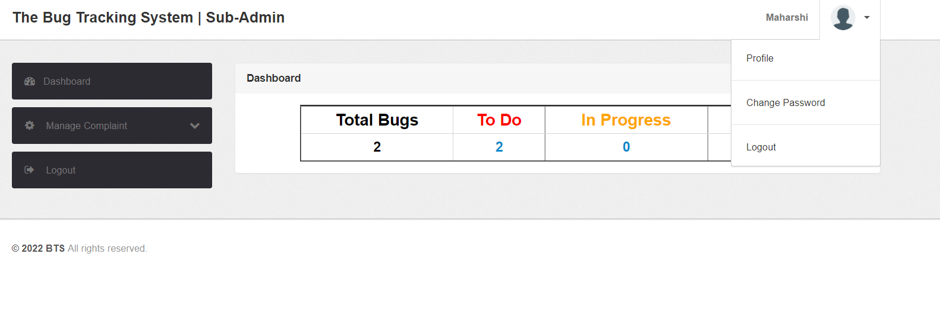

Figure 54: Employee Account settings

#### Profile:

“Profile” button will display manager profile information and edit/update personal information.

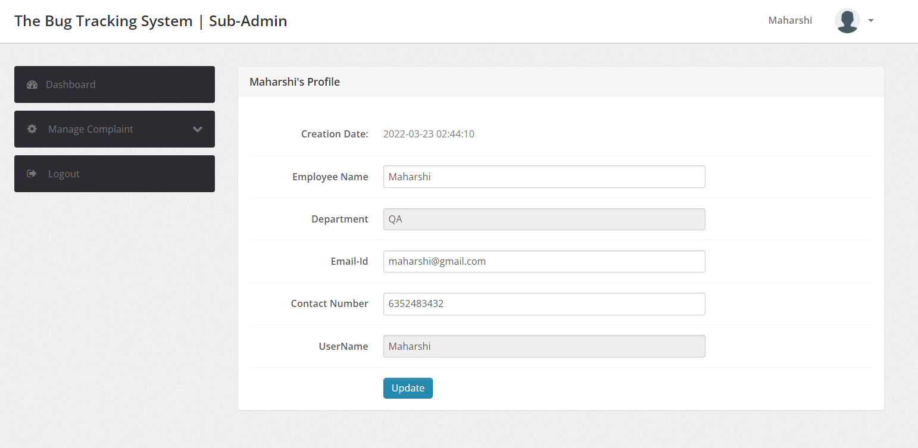

Figure 55: Employee Profile Information

#### Change Password:

“Change password” button is used for changing password. Enter Current password, new password and Confirm password fields and submit for updating the password. If current password is wrong, “Oh Snap! Old password does not match” error is popped.

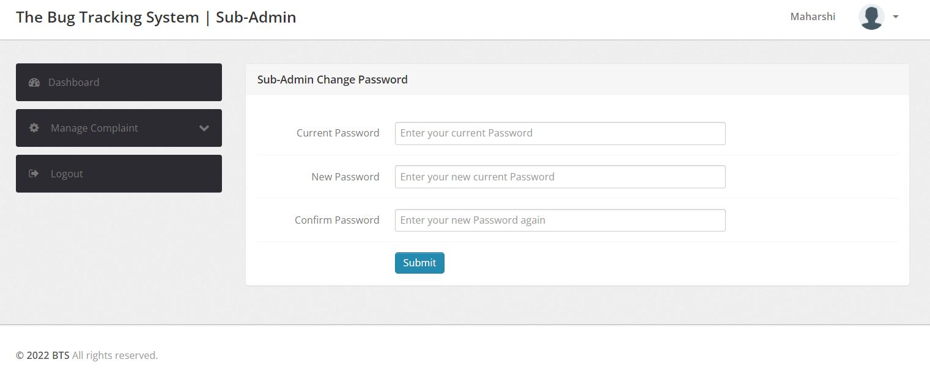

Figure 56: Employee Change Password Page

#### Logout:

User can logout just by clicking this button.



Figure 57: Employee Logout Page

### Dashboard:

Dashboard displays count of all the tickets the employee is currently working on.

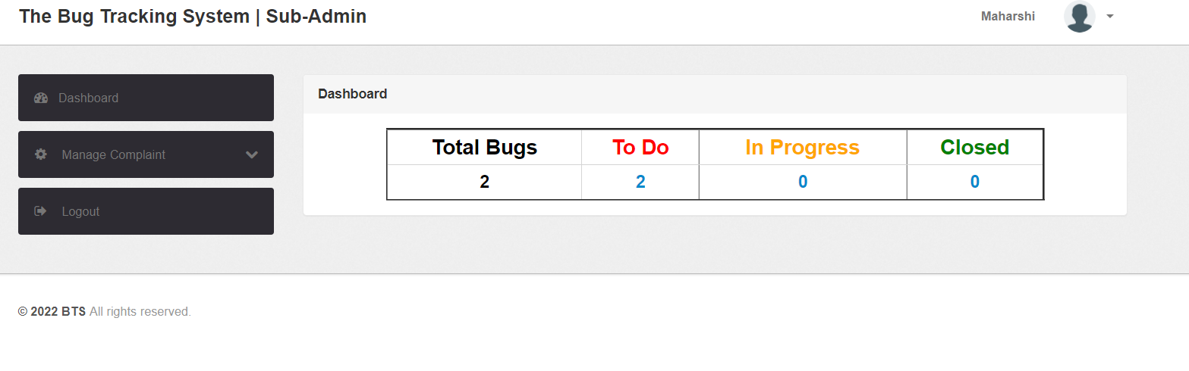

### Manage Complaints:

* This section shows all the To Do, Un-assigned, Closed and In Progress tickets.

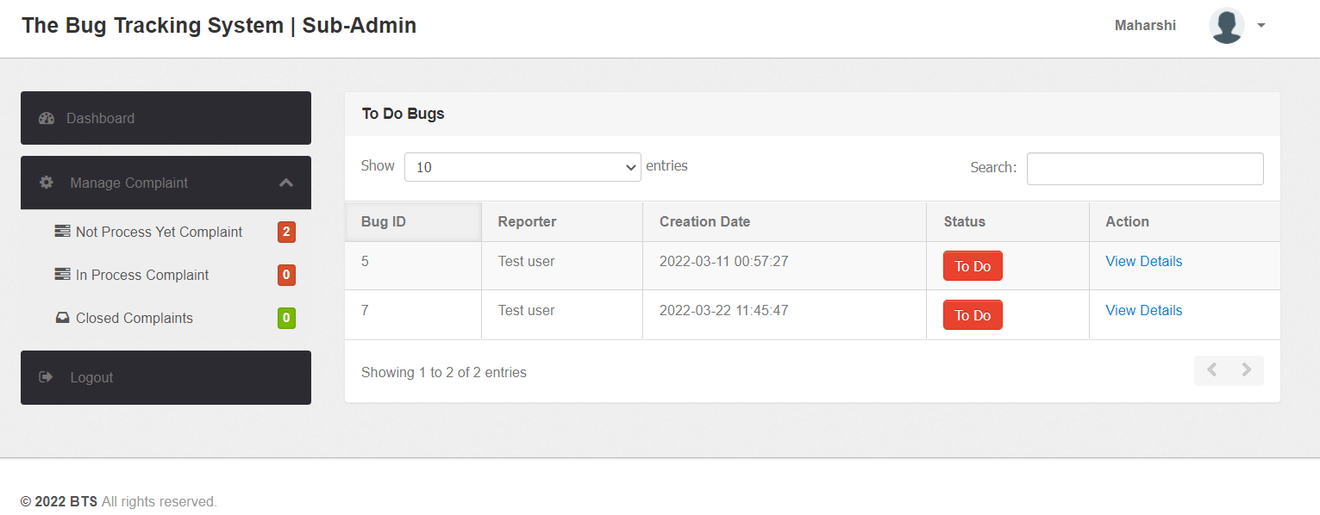

Figure 58: Employee Mange Complaints

* It displays Bug ID, Reporter, Creation Date, Status and Action Columns for the tickets.
* Click on “View Details” button in Action column against the Bug to view Bug Details. This will redirect to the Bug View.
* is assigned.

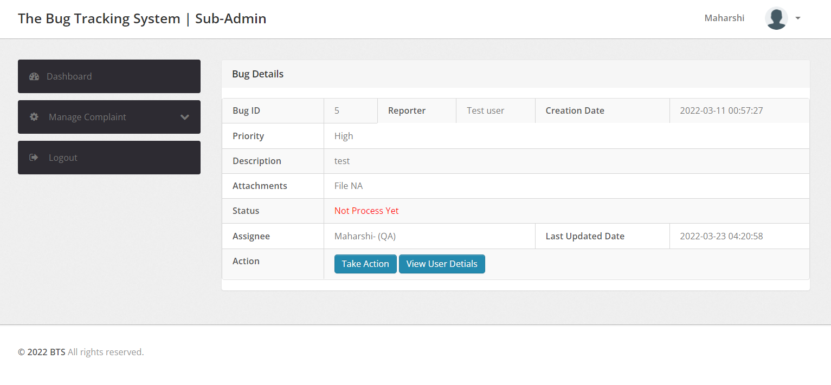

Figure 59: Employee Bug View

Action has two buttons “Take Action” and “View User Details”

* **Take Action:** This Button is used to update Bug status and add remarks. Click on “Submit” to update and “Close this window” to close the window.

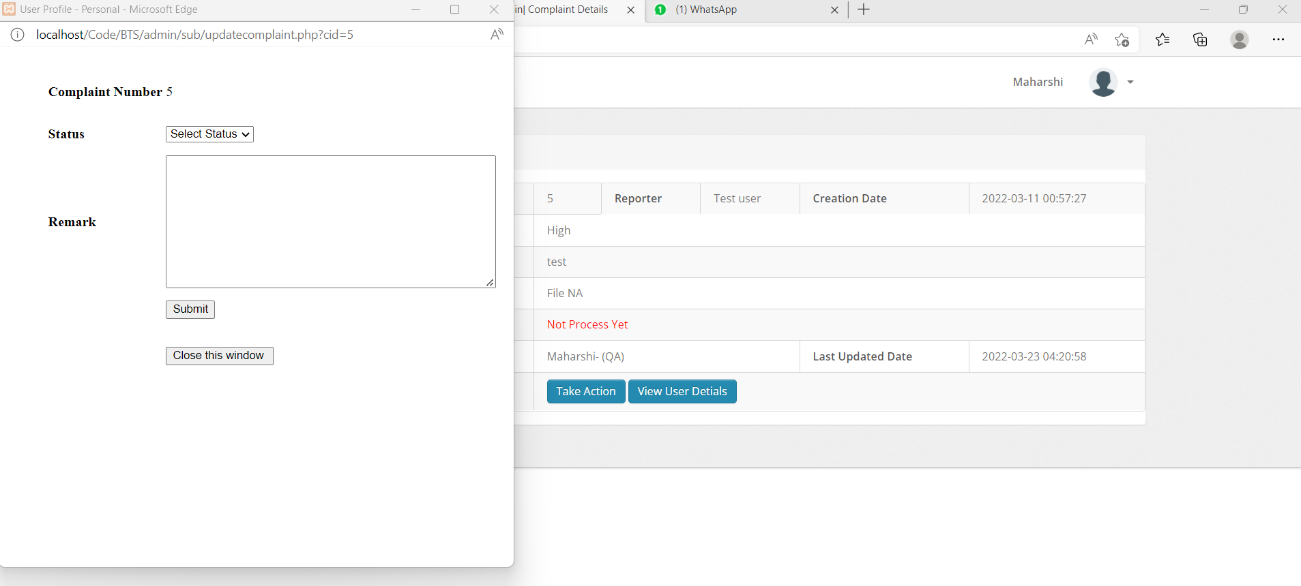

Figure 60: Employee Bug View Take Action button

* **View User Details**: This Button is used to display all the information of the Reporter.

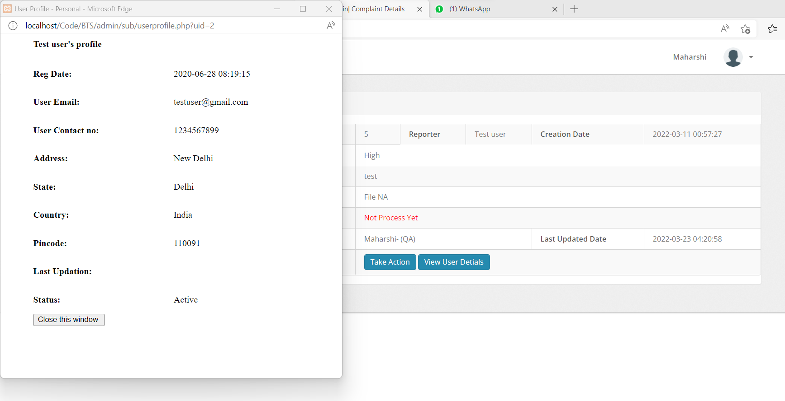

Figure 61: Employee Bug View "View User Details" Page

### Logout:

This button will log the user out.



Figure 62: Employee successful Logout

# Program Compilation and Run Instructions

## Program Instructions

As this is a PHP coded project, it does not need any compilation. Below are the run instructions:

* 1. Install Xampp on your system - <https://www.apachefriends.org/download.html>
  2. Open GitHub (<https://github.com/nehabaddam/Software-Engineering-Project.git>) and download file “[Software-Engineering-Project](https://github.com/nehabaddam/Software-Engineering-Project)/[Code](https://github.com/nehabaddam/Software-Engineering-Project/tree/main/Code)/**Phase-1**/BTS.zip” .Extract “BTS.zip” folder to C:\xampp\htdocs folder on the laoptop/PC.

Note: Make sure that the “BTS” folder is extracted and placed correctly in path C:\xampp\htdocs

* 1. Open the Xampp control panel and start the Apache and MySQL Modules.

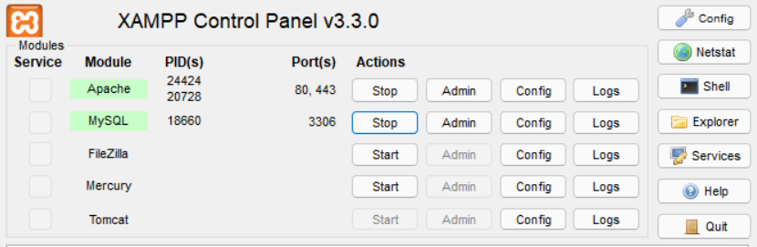

Figure 63: Xampp Control panel

* 1. Open PHPMyAdmin (<http://localhost/phpmyadmin>), Create a database with name bts and import the “bts.sql” file from the GitHub “Code/Phase-1” folder.

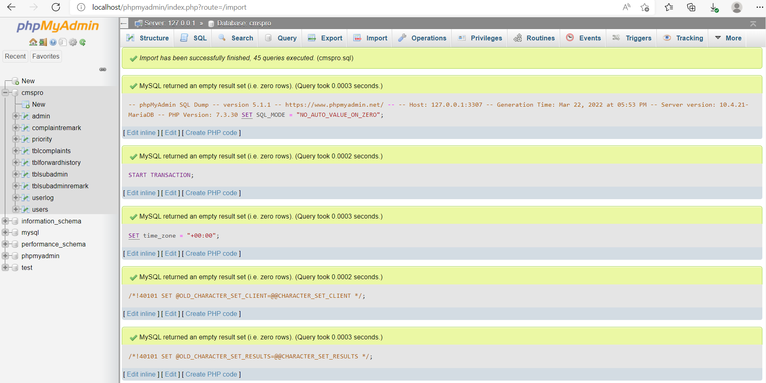

Figure 64: PhpMyAdmin

* 1. Type the URL <http://localhost/BTS>

## Testing Instructions

As it is web application, most of the test cases executed as a part of Phase-1 were directly tested on the browser. Below are the steps:

1. Firstly, Setup the Program by executing all the steps provided in the Program Instructions section.

2. Now, execute each test case provided in the test cases section of this document.

# Feedback

Feedback received:

1. We have been asked to add a download button for the project report at the manager end.
2. We were asked to include both sign-up and login page.
3. Email triggers were requested whenever the assignee is changed.
4. We were requested to add option to change password.

Actions taken based on the feedback:

1. We shall be implementing the download button for the project report at the manager end in Phase - 2.
2. We included both sign-up and login page for all users.
3. Email triggers have been added whenever the assignee is changed, we shall test this part thoroughly in Phase - 2.
4. We have included functionality to change the password at anytime.

# Accomplishments

A brief reflection on what has been accomplished, what went well and could be improved:

1. Developed Database tables.

We have used MySQL for Database creation. We have included more tables to fulfill the functionality.

1. Developed the application layer for the webpage.

We have used JAVASCRIPT for Application layer development. That helped in faster loading of webpages.

1. Developed Webpages for all Modules.

We used HTML, AJAX and JQUERY for the development of Webpages. As most of the team members were not aware of jQuery and Ajax, took us some time to train each other to complete the task.

1. Integrated Database with the Front-End applications.

We used HTML, AJAX, JQUERY and JAVASCRIPT for integration, also for login and registration validation. Few of the team members were not familiar with the coding languages being used, but frequent training and meetings helped in completing the Phase-1 version on time.

1. Developed back-end code for Customer, Manager and Employee Modules.

We used PHP and JAVASCRIPT for coding each component with respect to Customer, Manager and Employee Roles and authorities. During the development phase we realized that we needed few more functionalities to make the application work better. We have added those to Phase-1 requirements. We could have avoided that by proper requirement gathering and analysis in the initial phases.

1. Integrated Components in the Customer, Manager and Employee Modules with the Front-End Applications and the Database. This part was difficult that cost us more time than expected.
2. Performed Initial testing.

The application is deployed through XAMPP server, few test cases were prepared and tested as a part of initial testing.

# Member contribution table

|  |  |  |  |
| --- | --- | --- | --- |
| **Member Name** | **Contribution Description** | **Overall Contribution (%)** | **Note (If Applicable)** |
| **Neha Goud Baddam** | Functional and Non-Functional requirement specification and Full Stack Development, worked on all components. | 15 |  |
| **Vamsi Sai Konidena** | Program Compilation and Run Instructions. Front-end development of customer, employee, and manager modules. | 12 |  |
| **Reshmi Chowdary Divi** | Test Cases and Back-end development of customer, employee, and manager modules. | 12 |  |
| **Prem Kumar Maddula** | Feedback and accomplishments. Back-end development of customer, employee, and manager modules. | 12 |  |
| **Rahul Mandaloju** | Code-inspection document. Front-end development of customer, employee, and manager modules. | 12 |  |
| **Harika Uppalapati** | User Manual and Application Layer Development. | 11 |  |
| **Purandhara Maharshi Chidurala** | Code-inspection document and GitHub update and Application and UI Development. | 13 |  |
| **Shiva Surya Vardhan Reddy** | UML Designs and Initial Integrated Testing. | 13 |  |